African American Thinkers:
Throughout the early twentieth century, many black leaders tried to define the role of blacks in the society. Each had different ideas on the best way African Americans to be socially accepted and prosperous.
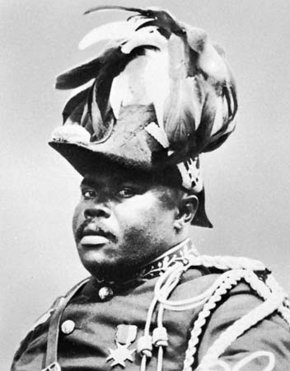
Marcus Garvey’s Back to Africa Movement
Marcus Garvey was a black leader who organized the first important American black nationalist movement (1919-1926), based in New York City’s Harlem. He had an idea called “Back to Africa” movement. He wanted African Americans to take pride in their African heritage (culture) and stated that “Black is Beautiful”, meaning that the black community should define beauty in their own terms and that beauty that has always existed in African people. Garvey believed that African Americans would never be rich and equal in America. He believed in order to be equal and achieve greatness, African Americans should leave the United States and move back to Africa where they can create their own country and be almost their own people.

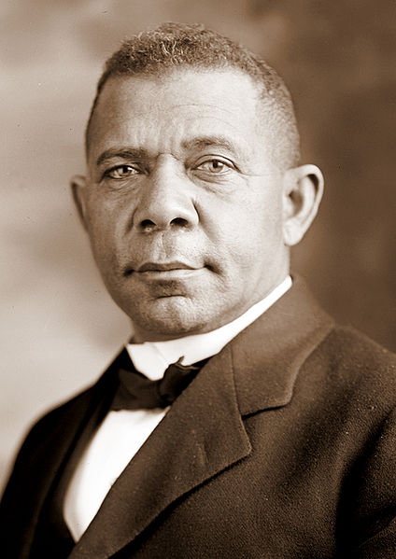

Booker T. Washington
Booker T. Washington was a former slave who became a teacher and writer. He started the Tuskegee Institute for training farmers, merchants, writers. Washington felt African Americans should temporarily do without having “political power, civil rights, and high education of Negro youth”. Rather, African Americans “should focus all their energies on industrial education”. He believed in education and better economic ($) conditions first. Washington urged blacks not to fight Jim Crow Laws (laws that restricted blacks from having equal rights). He felt that blacks should improve themselves through vocational education first, meaning that African Americans should do manual (physical) jobs that are not focused on academics, such a becoming a mechanic . Then, when African Americans were prepared, they should seek full rights. He also thought they should not take part in politics.

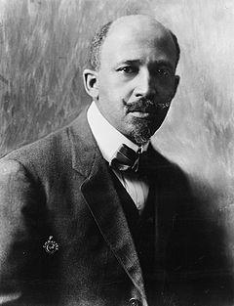William E.B Dubois
William E.B. Dubois was a black author and editor. He was the first African American to earn his PhD at Harvard. He believed in segregation laws (separation between blacks and whites) should change immediately. He felt that blacks should seek equal rights and opportunities now! In 1909, Dubois started the National Association for the Advancement of Colored People (NAACP). This was an organization that consisted of blacks and whites who fought for the rights of blacks. He also argued that social change could be accomplished by developing the small group of college-educated blacks he called “the Talented Tenth”. He stated "The Negro Race, like all races, is going to be saved by its exceptional (outstanding) men. The problem of education then, among Negroes, must first of all deal with the "Talented Tenth." It is the problem of developing the best of this race that they may guide the mass (the rest of the African Americans) away from the contamination and death of the worst."

DIRECTION: After reading through the different ideas of African American thinkers, match each photo to the thinker most likely to agree with it and EXPLAIN why.

Q. Which African American thinker would agree with this photo? EXPLAIN.

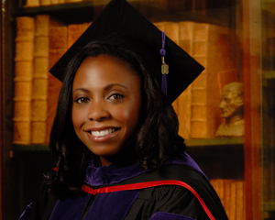

Q. Which African American thinker would agree with this photo? EXPLAIN.

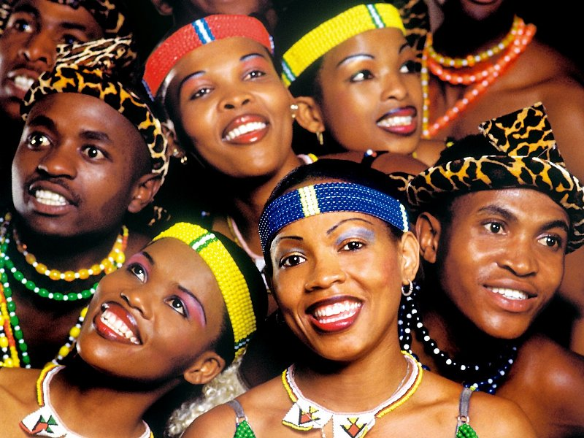

Q. Which African American thinker would agree with this photo? EXPLAIN.

