Edward R. Murrow High School Ms. Albu and Ms. Sarno
U.S. History Semester 2 Homework Packet

American History Homework Packet – Semester 2
These sheets are a Homework Packet. The homework assignments are made up of primary sources that will help you to answer the questions connected to the documents and give you a better understanding of the material to be covered in class.
- Write all assignments on a separate sheet of paper with your name, the date, your band, the HW number, and the questions.
- Each homework number will be assigned and complete answers are expected. Always give detailed explanations in your responses; use facts to back up your answers. Write in paragraph form. One sentence answers are not acceptable, nor are incomplete assignments, lists, charts. All answers need to be complete and thorough. All of your answers MUST be in your own words.
- Homework is graded on a scale of 1-3 (3 being the highest grade possible).
- You are responsible for making sure that that your homework is handed in on time. If you are absent, it is your responsibility to make sure that you make up your homework assignment and hand it in. Late homework will receive a grade no higher than a 2. Homework assignments that are not completed fully or not answered correctly will have to be redone. If you do not like your homework score, you will be able to redo them and resubmit them.
-----------------------------------------------------------------------------------------------------------------------------------
- World War I – American Neutrality
Read through the information below and answer the questions that follow.

Causes for WWI
Nationalism | At this time, many Europeans also had strong feelings of nationalism toward their homelands. People supported the actions of their government, even if it was wrong. Others wanted their independence.
Militarism | New weapons, such as submarines, tanks, poison gas, machine guns, and airplanes were invented. This made warfare much more deadly and expensive. European nations also expanded their armies and navies. This race for naval dominance strained relations between the two nations.
Imperialism | Imperialism also fueled rivalries among powerful nations. Between 1870 and 1914, Britain, France, Germany, Italy, and Russia scrambled for colonies in Africa, Asia, and the Pacific. Often, several nations competed for power in the same region. This competition sometimes led to wars in places far from Europe.
Alliances | To protect themselves, European powers formed rival alliances so that they can help each other. Germany organized the Triple Alliance with Austria-Hungary and Italy. France responded by linking itself to Russia and Britain in the Triple Entente.

“My fellow Americans: The effect of the war (World War I) upon the United States will depend upon what American citizens say and do. Everyone who really loves America will act and speak in the true spirit of neutrality (not to take any sides), which is the spirit of fairness and friendliness to all concerned. The people of the United States are drawn from many nations, and chiefly (mainly) from nations now at war.”

  - What were the reasons European nations went to war in 1914?
  - What does President Woodrow Wilson think we should do? Explain.
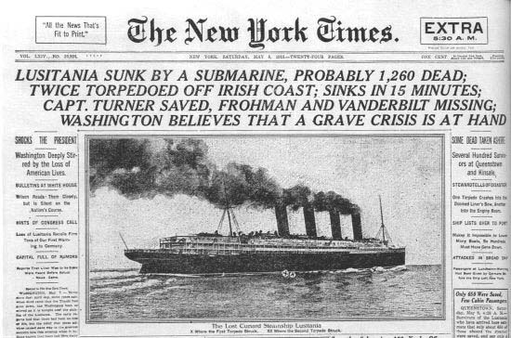

The war in Europe affected American shipping and trade. Great Britain set up a blockade along the German coast to keep goods from getting through. America said nothing about the British blockade. As a result, German U-boats (submarines) sank ships from all nations. In 1915, a German U-boat sank the British ship Lusitania, killing more than a thousand people, including 128 Americans.

- Should the United States have entered World War I as a result of the sinking of the Lusitania?

- Civil Liberties and World War I:
Read the passage below and answer the questions that follow.

Another jailed dissenter (someone who speaks out against the government), Charles Schenck, had mailed pamphlets encouraging draftees (someone who was drafted into the army – legally people must serve in the army if they are drafted) to refuse to serve in the army. Schenck was arrested but appealed to the Supreme Court of the United States arguing that his First Amendment rights to freedom of speech had been denied. In Schenck v. United States (1919), the Court ruled against Schenck stating that someone’s words can present a “clear and present danger” to the public and that the First Amendment “would not protect a man in falsely shouting fire in a crowded theater.”

  - Why was Charles Schenck arrested?
  - Explain the Court’s decision. Do you agree or disagree with the Supreme Court’s decision? Why or why not.

- Post War Peace – Wilson’s 14 Points vs. The Treaty of Versailles
Read the quotations from the “Big Four” below and answer the questions that follow.
“We must seek peace without victory!” We should not look to punish those who have lost the war. We should look to create a League of Nations to work together to create a long lasting peace!”
We must PUNISH Germany for what they have done to us and the world! We must make sure they will never start another war again!

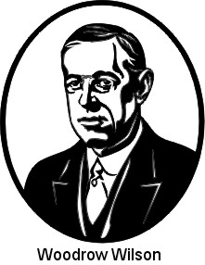

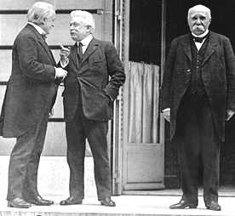

Three of the “Big Four” (Winners of WWI): American President
David Lloyd George of Britain, Vittorio Orlando
during WWI of Italy, Georges Clemenceau of France

a. How are the views of Britain, France, and Italy different from those of America regarding post-
war peace?
b. Which side do you agree with more? Explain!

- Intolerance in the 1920s
Intolerance – not willing to accept something (or someone) different or not willing to accept a difference of opinion

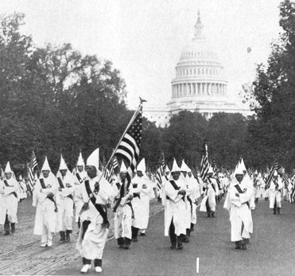  Ku Klux Klan Marches in Washington -1925  In the 1920s, the KKK made a comeback. The revived Klan’s targets were African Americans, Roman Catholics, Jews, and immigrants. | 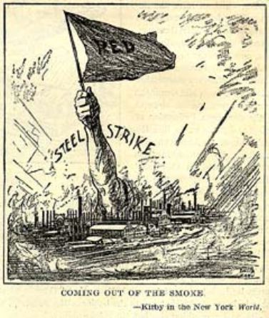  Red Scare  Many feared that the increase of worker’s strikes around the country meant that communism was coming to the United States (“Red” is a term used to describe communism). Hundreds of people, many of whom were immigrants, were arrested for supporting communist beliefs. | 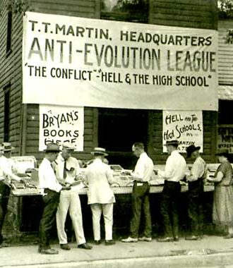  Scopes Trial -1925  In 1925, John scopes, a biology teacher, went against a Tennessee law that that banned the teaching of evolution (the scientific theory that humans evolved from ape-like creatures.) and he was arrested. | 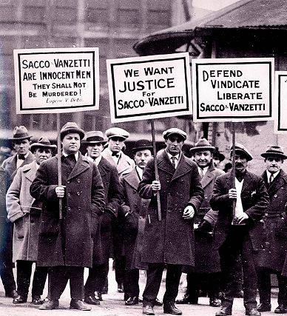  Sacco and Vanzetti  In 1921, Nicola Sacco and Bartolomeo Vanzetti were arrested and convicted for armed robbery and murder. The evidence against the two Italian immigrants was weak. Many argued that the judge was anti- (against) foreigner/immigrant.

- Create an outline that describes how the four examples above were examples of intolerance in the 1920s
(You must example it IN YOUR OWN WORDS!). Use the template to the right to guide you.
- Intolerance in the 1920s
  - The Rebirth of the KKK

  - Red Scare

  - Scopes Trial

  - Sacco and Vanzetti

.

- Prohibition

1919 | 1933
“After one year from the ratification of this article the manufacture, sale, or transportation of intoxicating liquors within, the importation thereof into, or the exportation thereof from the United States and all territory subject to the jurisdiction thereof for beverage purposes is hereby prohibited.”  -18th Amendment – US Constitution | 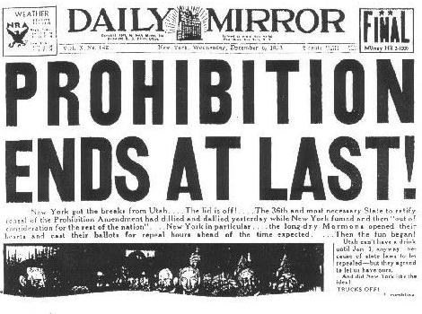

- The 18th Amendment of the US Constitution is often called the Prohibition Amendment? Based on the 18th Amendment, what do you think prohibition is?
- Why do you think prohibition was repealed (cancelled) in 1933?

- Great Depression Begins!
Read the passage below and answer the questions that follow.

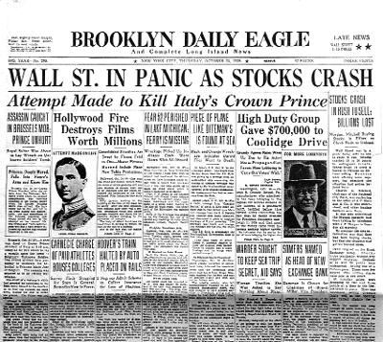
The Roaring Twenties ended with a crash. On “Black Tuesday,” October 29, 1929, the stock market “crashed,” which means that the value of stocks (ownership of a company) dropped by a huge amount. Millions of people had invested their life savings in the stock market, and as a result many people lost everything (their money, homes, etc.). The Great Depression had begun. So what happened? During the 1920s, people believed that the value of stocks would keep rising and some people got greedy. They began investing in the stock market in risky ways. Some people borrowed money from banks to buy stocks. That means that they were buying “on margin.” When the market crashed, they couldn’t repay their loans to the banks. With so many people unable to repay, many banks themselves had to close because they were not getting their money.
  - Describe the Stock Market Crash of 1929.
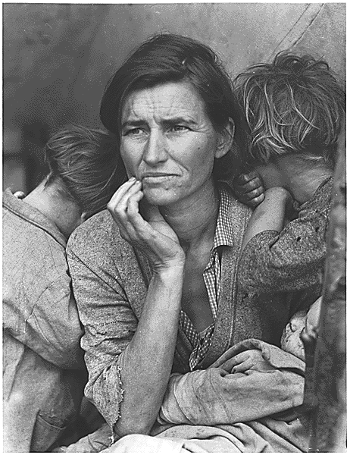
  - How did the Stock Market Crash of 1929 affect the United States?

- The Great Depression
Analyze the picture below and answer the questions next to the picture.

  - The picture to the left is one of the most famous pictures taken during the Great Depression Analyze the picture and:
    - Give the picture a title
    - Write a diary entry as if you were this woman in the picture. Describe your thoughts and concerns and what you may be experiencing.

- FDR vs. Hoover –
Read the chart below and answer the questions that follow.

1932 Presidential Election
Franklin D. Roosevelt (Democrat) | Herbert Hoover (Republican)
- FDR ran on the idea that the government should create reforms (changes) for the unemployed and provides work for people to help get the United States out of the Great Depression. People would go to work, make money and then go out and spend it which would help businesses.  - FDR was for more control of the American economy | - Hoover supported programs that helped businesses on the idea that if businesses improve, the economic benefits would “trickle down” to the workers and people. If businesses get money from the government, they would expand their businesses, hire more workers, and more workers would make money and start spending.  - Hoover supported a laissez-faire approach (the government should not get involved in the economy)
Some points to know:
    - The country is the middle of a severe economic crisis in 1932 – the Great Depression
    - The American people were not happy with Herbert Hoover since the country was experiencing the hardships of the Great Depression for several years while Hoover was President.
- Who would you have voted for in 1932? Explain why.
- Why were so many Americans angry with Herbert Hoover?

- FDR and the New Deal
Read through the chart and answer the questions.

New Deal Agencies
Agency | Purpose
Civilian Conservation Corps | Provided jobs to young men to work on environment conservation (protection) projects.
Works Progress Administration | Gave the unemployed work in building construction and arts projects
Public Works Administration | Sponsored huge public works projects such as dams
National Recovery Administration | Worked with industries to ensure fair business and labor practices
National Labor Relations Board | Enforced rights of workers and unions
Federal Deposit and Insurance Corporation | Insured people’s bank deposits up to $5,000

- Pick three new agencies that FDR created during the New Deal.
- Explain what problems each agency was trying to fix.
- Do you think this agency can fix these problems? Why or why not?

- An Evaluation of FDR:
(Read the chart below and answer the question that follows)

Arguments FOR and AGAINST FDR’s Presidency
For  + Gave immediate relief to those without food or shelter  + Completed works projects like roads, buildings, bridges, and dams.  + Prevented financial disaster  + Created new agencies, such as FDIC, to protect people who wanted to put money in a bank from bank failures.  + Federal government should oversee the smooth running of the United States economy. | Against  - Increased the national debt through the government spending programs.  - increased taxes to pay for the new programs.  - allowed federal government to control business.  - created the “welfare state” which supports the idea that the government will get involved in the lives of the people whenever they need.

  - Do you think that FDR was good for the United States? Be sure to refer to and explain several reasons that are listed in the chart (Be sure to explain your answer IN YOUR OWN WORDS!)

- American Neutrality- WWI
Read the quote below and answer the questions that follow.

“In the present world situation, there is no doubt in the minds of an overwhelming number of Americans that the best immediate defense of the United States is the success of Great Britain in defending herself. Quite aside from our historic and current interest in the survival of democracy, therefore, it is important from the selfish viewpoint of American defense that we should do everything to help the British Empire defend itself…. Suppose the house of the President’s neighbor catches fire and he has a length of garden hose, 400 or 500 feet. If he can take the hose and connect it to the neighbor’s hydrant, he may be able to put out the fire. He does not say his hose costs $15; pay me $15. He doesn’t want $15, but his hose back when the fire is over. The neighbor gives back the hose and pays him for the use of it. If it gets smashed in the fire, the President says he was glad to lend it. The neighbor says he will replace the part destroyed. If the President has got back his hose, he has done a pretty good job….”
      - President Franklin D. Roosevelt Explains Lend Lease (December 17, 1940)

- What does FDR want to do?
- Why did FDR suggest this policy of “Lend Lease?”

- Pearl Harbor – America Enters World War II
Read the quote below and answer the questions that follow.

“Yesterday, December 7, 1941, - date which will live in infamy – the United States of America was attacked by the Empire of Japan…. I ask Congress to declare war because since the attack by Japan, a state of war has existed between the United States and the Japanese Empire…”
- President Franklin Roosevelt (1941)
- What is FDR asking Congress?
- If you were President Roosevelt, would you have made the same request from Congress?

- Japanese Internment
Read the quotation below and answer the questions that follow.

“I am for the immediate removal of every Japanese on the West Coast to a point deep in the interior. I don’t mean a nice part of the interior either. Herd ‘em up, pack ‘em off and give ‘em the inside room in the badlands... Let ‘em be pinched, hurt, hungry, and dead up against it... If making one innocent Japanese uncomfortable would prevent one scheming Japanese from costing the life of one American boy, then let the million innocent suffer... Personally, I hate the Japanese. And that goes for all of them.”
-Henry McLemore, Columnist for Hearst Newspapers

- What does Mr. McLemore want to do?
- Why would he have such feelings towards the Japanese living in the United States?

- Cold War
Look over the charts below and answer the question that follows.

Features of Capitalism
(US)
Private Property
People have a right to own property (homes, businesses, farms) and to use their property as they see fit.
Profit Motive
People can start and own businesses and do any legal job they want to make money.
Supply and Demand
People have a right to buy and sell any legal products.
Free Enterprise
People are free to take part in business, and to buy and sell any product. Businesses can do anything legal to attract customers.

Features of Communism
(USSR)
Role of Government
Decisions about production and resources are made by the government for the good of all workers.
No Private Property
The owning of private property is abolished.
Major Goal
The main goal is a classless society – total equality among all workers, no matter who they are or what job they perform. Then the government will “wither away.”
Cooperation
Communism is based on cooperation, in which workers in society labor together and share equally the benefits.

  - Why would the people of the United States not like communism? Explain.

- McCarthyism
Read and answer the multiple choice questions below.
**MAKE SURE TO FOLLOW THESE DIRECTIONS**:
1- WHAT ARE THE KEY WORDS IN THE QUESTION?
2- WHICH ANSWERS CAN YOU RIGHT AWAY ELIMINATE
3-WHAT IS THE ANSWER

1. The growth of McCarthyism in the early 1950s was based on
- public fear concerning the spread of communism
- outrage over government corruption
- dissatisfaction with the results of World War II
- opposition to the policy of containment

2. “Which situation resulted from Senator Joseph McCarthy’s search for Communists within the United States during the 1950’s?
- Thousands of American citizens who believed in communism were either jailed or deported.
- The reputations of many people were ruined by false accusations of disloyalty
- Many high-ranking government officials were exposed as spies of the Soviet Union.
- Organized groups of Communists began a wave of violent political terrorism.

3. In the 1950’s, Senator Joseph McCarthy was most closely associated with issues related to
- Communist infiltration and the denial of civil liberties
- farm problems and taxation
- military preparedness and foreign aid
- collective bargaining and the rights of unions
- The Civil Rights Movement – Brown v. Board of Education
Read the passage below and answer the questions that follow.

The 1954 United States Supreme Court decision in Brown v. Board of Education of Topeka (KS) is among the most important Supreme Court cases in United States history. Brown overturned the 1896 ruling in Plessy v. Ferguson (Remember cycle II???) that established the doctrine of “separate but equal” and ended racial segregation in schools and other public facilities: Here is the decision in the case:

“Does segregation of children in public schools solely on the basis of race, even though the physical facilities and other factors may be equal, deprive (take away) the children of the minority group of equal educational opportunities? We believe that it does.... To separate them from others of similar age and qualifications solely because of their race generates a feeling of inferiority as to their status in the community that may affect their hearts and minds in a way unlikely ever to be undone....”

- What was the ruling in the Brown v. Board of Education case?
- How do you think Southern whites who supported segregation would feel about the ruling? EXPLAIN.

- Martin Luther King Jr.
“Violence often brings about momentary results...but...it solves no social problem; it merely creates new and more complicated ones.... The nonviolent resisters can summarize their message in the following simple terms: We will take direct action against injustice without waiting for other agencies to act. We will not obey unjust laws or submit to unjust practices. We will do this peacefully, openly, cheerfully because our aim is to persuade. The way of nonviolence means a willingness to suffer and sacrifice. It may mean going to jail.... It may even mean physical death.... What is the Negro’s best defense against acts of violence inflicted upon him? His only defense is to meet every act of barbarity, illegality, cruelty, and injustice toward an individual Negro with the fact that 100 more Negroes will present themselves in his place as potential victims.”

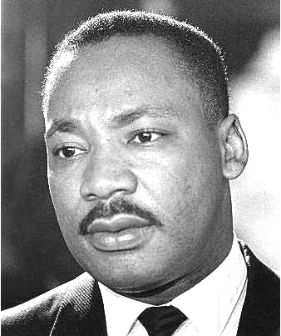

Martin Luther King, Jr. (1958)

- Describe Martin Luther’s King’s views?
- Do you agree with his views? EXPLAIN.

- Black Power Movement

“I have to respect the believer in nonviolence because he is doing something I do not understand. It would be equivalent to putting handcuffs on me and putting me in the ring and telling me to fight Cassius Clay (Mohammed Ali) nonviolently. I don’t think I can do it. But what I am saying is this, whenever you are dealing with an enemy, you have to be able to communicate. You want to speak the language that the other person understands. When you’re in Mississippi speaking the language of nonviolence, you are not communicating, you are talking a language that they don’t understand.) - Malcolm X

Black Panther Party Platform and Program: What We Want, What We Believe (October 1966)
- We want freedom. We want power to determine the destiny of our Black Community.
- We want full employment for our people.
- We want an end to the robbery by the white man of our Black Community.
- We want decent housing, fit for shelter of human beings.
- We want education for our people that exposes the true nature of this decadent American society. We want education that teaches us our true history and our role in the present-day society.
- We want all black men to be exempt from military service.
- We want an immediate end to police brutality and murder of black people.
- We want freedom for all black men held in federal, state, county and city prisons and jails.
- We want all black people when brought to trial to be tried in court by a jury of their peer group or people from their black communities, as defined by the Constitution of the United States.
- We want land, bread, housing, education, clothing, justice and peace. And as our major political objective, a United Nations-supervised plebiscite to be held throughout the black colony in which only black colonial subjects will be allowed to participate for the purpose of determining the will of black people as to their national destiny.

- How does Malcolm X feel about Martin Luther King’s method of nonviolence? EXPLAIN.
- How is the Black Panther Party different from Dr. King and his supporters?

- The Warren Court
Read the passage below and answer the questions that follow.

The events of the Kennedy and Johnson years cannot be understood without reference to the “Warren Court.” During the 1950s and 1960s, the United States Supreme Court under Chief Justice Earl Warren became a strong supporter of civil rights in such cases as the Brown v. Board of Education (Supreme Court declared segregation in public schools to be unconstitutional). The Warren court also acted as a strong supporter of the rights of defendants in criminal cases. Some people criticized the Warren Court for going too far in protecting the rights of the accused, making it more difficult for the police to capture and convict criminals. But supporters of the Warren Court argued that the Court had a constitutional duty to protect individual rights. The Court, under Warren, became a major instrument of social change, protecting rights that other institutions of government seemed too weak to defend. Other cases under Chief Justice Earl Warren:

Gideon v. Wainwright (1963) | Miranda v. Arizona (1966)
Background: Clarence Gideon was arrested for robbing a pool hall. He was too poor to have a lawyer and was not provided one by the government.  Ruling: The Court ruled that Gideon’s 6th Amendment rights to a lawyer were violated. The decision required all states to provide free legal services to any defendant who cannot afford them. | Background: Ernesto Miranda was arrested for kidnapping and raping a young woman. After appearing in a police line-up, Miranda confessed. The police never told him that he had a right to remain silent, that he did not have to answer their questions, and that he could have their lawyer preset to advise him.  Ruling: The Supreme Court overturned Miranda’s conviction. The police are now required to warn all suspects that their statement could be used against them and to inform tall suspects of their constitutional rights to remain silent and to have a lawyer present. They are now known as the “Miranda rights.”

- How would supporters of the Warren Court feel about the rulings of the cases above?
- Do you agree with the Court’s decision in both cases? EXPLAIN.

- President John F. Kennedy
Read the selections below and answer the questions that follow.

President JFK was elected in 1960 and became the youngest President in the history of the United States. In his inaugural address he called on people to:
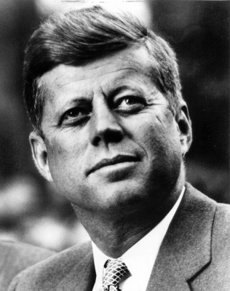
“Ask not what your country can do for you, but ask what you can do for your country…”

Kennedy’s New Frontier program include proposals for federal aid to education, greater Social Security benefits, assistance to the poor, protection of African American civil rights and more health insurance for the elderly. However, Kennedy was only able to pass just a few of his programs before he was assassinated in 1963:
- Funds for urban (city) renewal to rebuild rundown, and poor, city neighborhoods.
- Funds to aid the poor in certain areas around the country.
- Raise the minimum wage from $1.00 to $1.25.

a. What did JFK mean when he said: “Ask not what your country can do for you, but ask what you can do for your country?”
b. Do you think your country comes before yourself? Explain.

You are the President of the United States in 1962 and you have just been informed that American spy planes discovered Soviet nuclear missiles in Cuba (Cuba is just 90 miles away from Florida). Cuba is ruled by Fidel Castro, who is Communist. Not only is a communist nation in the Western Hemisphere but nuclear missiles are now aimed at the United States.

- If you were President John F. Kennedy, how would you handle this situation? (Be sure to thoroughly EXPLAIN your decision and why you chose to handle the threat this way.)

- Lyndon Johnson’s Great Society
Read the quotations below and answer the question that follows.

“My first job after college was a teacher in Cotulla, Texas, in a small Mexican America school…Somehow you never forget what poverty and hatred can do when you see its scars on the hopeful face of a young child. It never even occurred to me in my fondest dreams that I might have the chance to help the sons and daughters of those students and to help people like them all over this country. But now I have that chance – and I’ll let you in on secret: I mean to use it! ”- Lyndon Johnson (1963)

“I have called for a national war on poverty. Our objective: total victory!” - President Lyndon Johnson (1964)

a. How does LBJ’s quote from 1963 help us to understand his statement from 1964?

- Vietnam War
Read the quotations below and answer the questions that follow.

“A Losing War: No one can assure you that we can beat the Vietcong or even force them to the conference table on our terms, no matter how many hundred thousand white, foreign troops we deploy (send to fight). No one has demonstrated that a white ground force of whatever size can win a guerilla war in a jungle terrain in the midst of a population that refuses cooperation to the white forces (and the South Vietnamese).
-Undersecretary of State George Ball (July 1, 1965)

“U.S. military spokesmen have often said that their greatest problem is finding the enemy. The enemy is everywhere. The old woman feeding her chickens may have a stock of hand grenades in her hut. The little boys, who trail after American soldiers during the day, slip out to give information to the guerillas at night. The washerwomen at the American air base bring a bomb to work one day. It is impossible to tell which are the Vietcong and which are the civilians.”
-Vietnam Day Committee Pamphlet (May 1965)

- What are some of the problems that American soldiers are facing in Vietnam?
- According to the sources above, is Vietnam a winnable war? EXPLAIN.

- The Anti-War Movement
Evaluate the pictures below and answer the questions that follow.
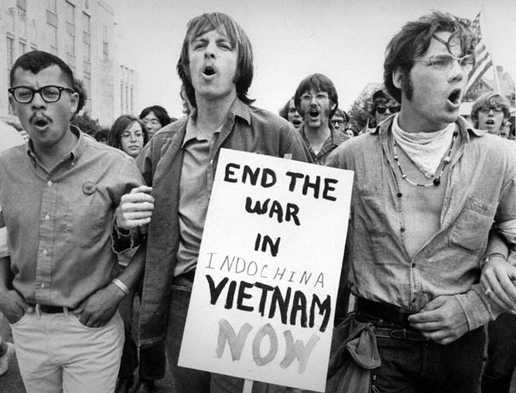
Picture A Picture B
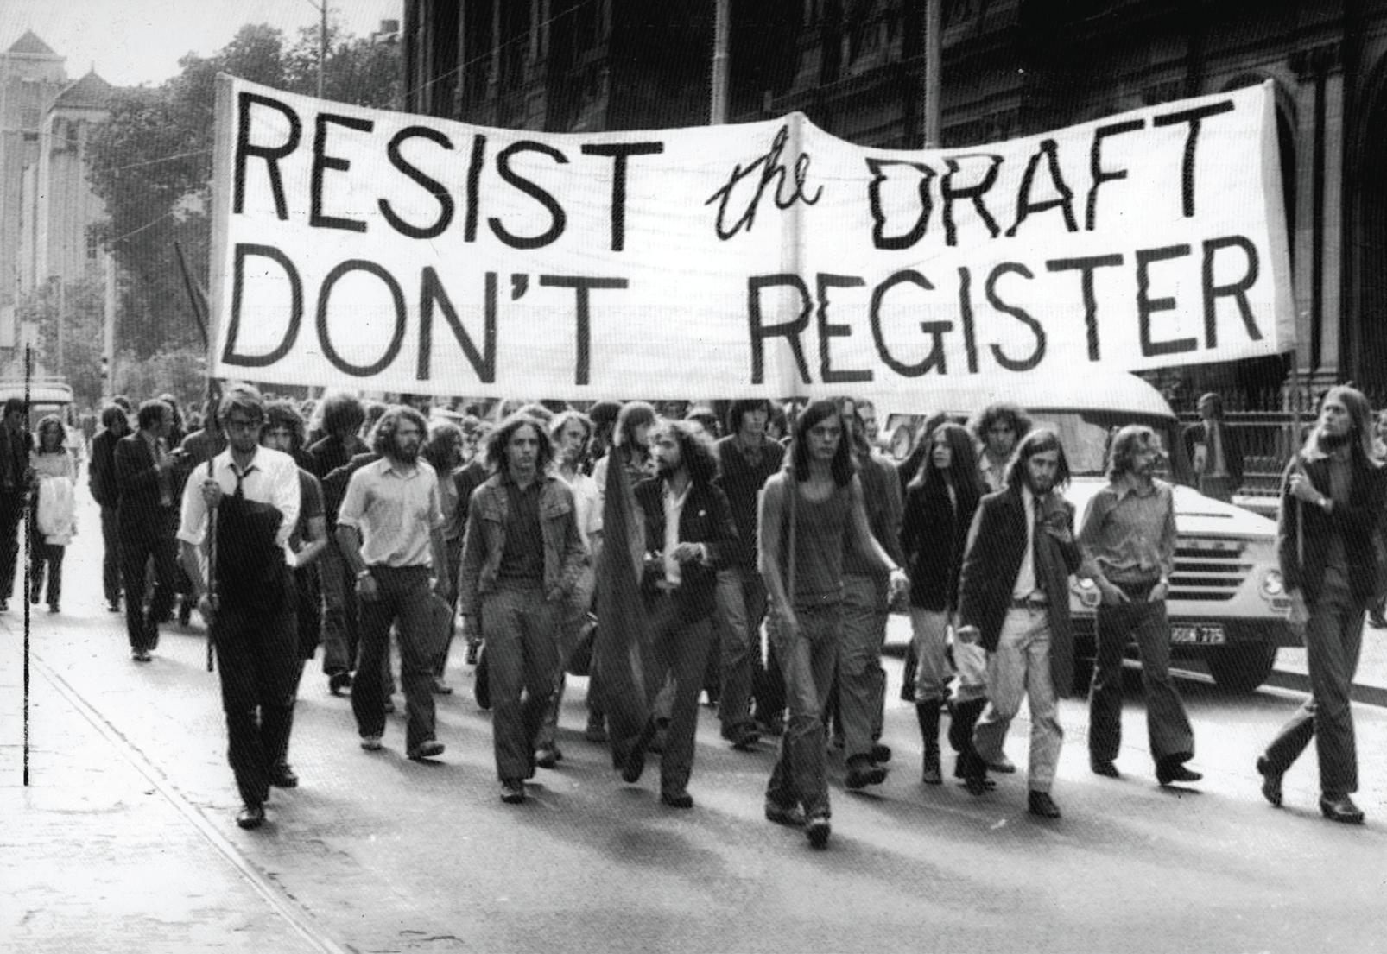

- What is/are the goal(s) of the people in each picture?
- Are these effective ways to achieve their goals? EXPLAIN.

- Richard Nixon
Read the chart and headlines below and answer the questions that follow.

Highlights of Nixon’s Foreign Policy
Ending the Vietnam War  (1969-1973)  Nixon shifted the fighting from American troops to the South Vietnamese army, and began withdrawing U.S. forces. This process was called Vietnamization. While Nixon promoted Vietnamization, he also gave the orders to bomb neighboring Cambia, which he claimed served as a base for the North Vietnamese guerillas. | Re-Opening Relations With  China (1972)  Ever since the communist takeover if China in 1949, the United States had refused to establish diplomatic relations with the government there. Nixon visited Communist China and restored normal diplomatic relations. | Detente With the Soviet Union (1972)  Nixon introduced détente (relaxing or cooling off of tensions with the Soviet Union). In 1972, he became the first president to visit Moscow. He also agreed to sell American grain to the Soviet Union to seas a severe food shortage there. In Moscow, Nixon opened what became known as the SALT Agreement. Strategic Arms Limitations Talks which set limits on the number of missiles each nation would keep.

- If you were giving Richard Nixon a grade (N, S, G, E) on his foreign policy. What would you give it and why?

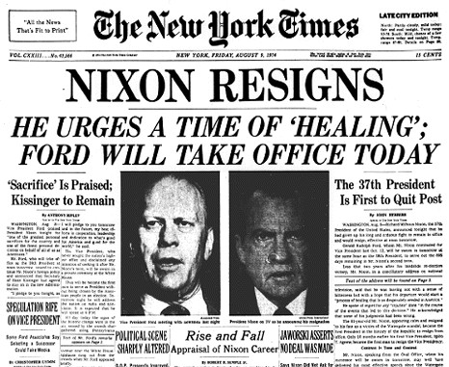
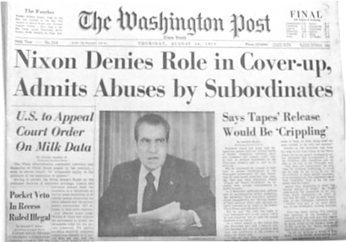

  - What does “resign” mean?
  - Why do you think President Nixon resigned from office?

