Edward R. Murrow High School Ms. Sarno & Ms. Albu
#9
Allen Barge, Principal American History Semester 2

Effects of the Great Depression in the 1930’s
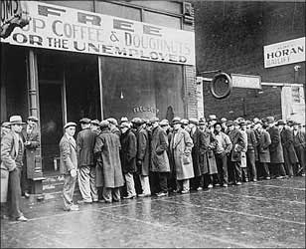
Introduction:
In 1932, 12 million workers — 25 percent of the labor force— were unemployed (without jobs). Herbert Hoover was the president at the time when the Great Depression began. The employed worked for much lower wages than in the 1920s. Prices paid to farmers were desperately low. Factories produced only half of what they normally made. About 5,000 banks had closed their doors, forever cutting off depositors (people putting money in banks) and savings.

Directions: Read each document and answer the questions that go with those documents below.

Station: Elderly and African Americans

Q. Why did the elderly and African Americans suffer during the Great Depression?

Station: Unemployment

Q. What do the song and the photo show you about unemployment? ______

Station: Children

Q. What conditions did the children live in during the Great Depression?
Q. What did the child who wrote the letter to Mrs. Roosevelt hope to gain? ______
Q. Why were “Hoovervilles” created? Why were they called “Hoovervilles?” ______
Station: Free Food for the Needy

Q. Analyze the pictures and describe what you see. ______
Q. What do these lines tell us about urban (city) areas in American during the Great Depression? ______

Station: Unemployment Pictures

Q. Describe the signs the people are holding. ______
Q. What does the man mean by “work is what I want and not charity?” _______
NAME: __________________________________________ BAND: ________

CAST YOUR VOTE!
DIRECTIONS: READ THROUGH THE DIFFERENT IDEAS OF PRESIDENTIAL CANDIDIATES HERBRET HOOVER AND FRANKLIN D. ROOSEVELT. THEN FILL IN THE BALLOT TEMPLATE BELOW.

HERBERT HOOVER’S IDEAS | FRANKLIN D. ROOSEVELT’S IDEAS
Hoover believed that if you were in trouble, you should help yourself and not expect others to help you. This he called “rugged individualism”. Hoover’s plan was to give banks and the railroads money. The idea was that the banks and railroads would help stop industry and agriculture (farms) from failing and would help people get back to work. This idea is called the “trickle down” effect – like when rain trickles down. If the wealthiest in society get the relief first, they will be able to use it to help others by offering jobs, giving loans, and providing opportunities to the poor.  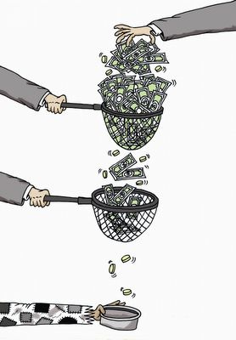 | FDR believed that the government should try to find solutions to some of the problems people were experiencing due to the Great Depression. This would help people get jobs and afford food and housing again. If people are making money, they will be able to buy goods again. This would help the economy. This idea is called “immediate relief”. FDR believed the government could create jobs for people that would help make the country stronger. This is called priming pump.  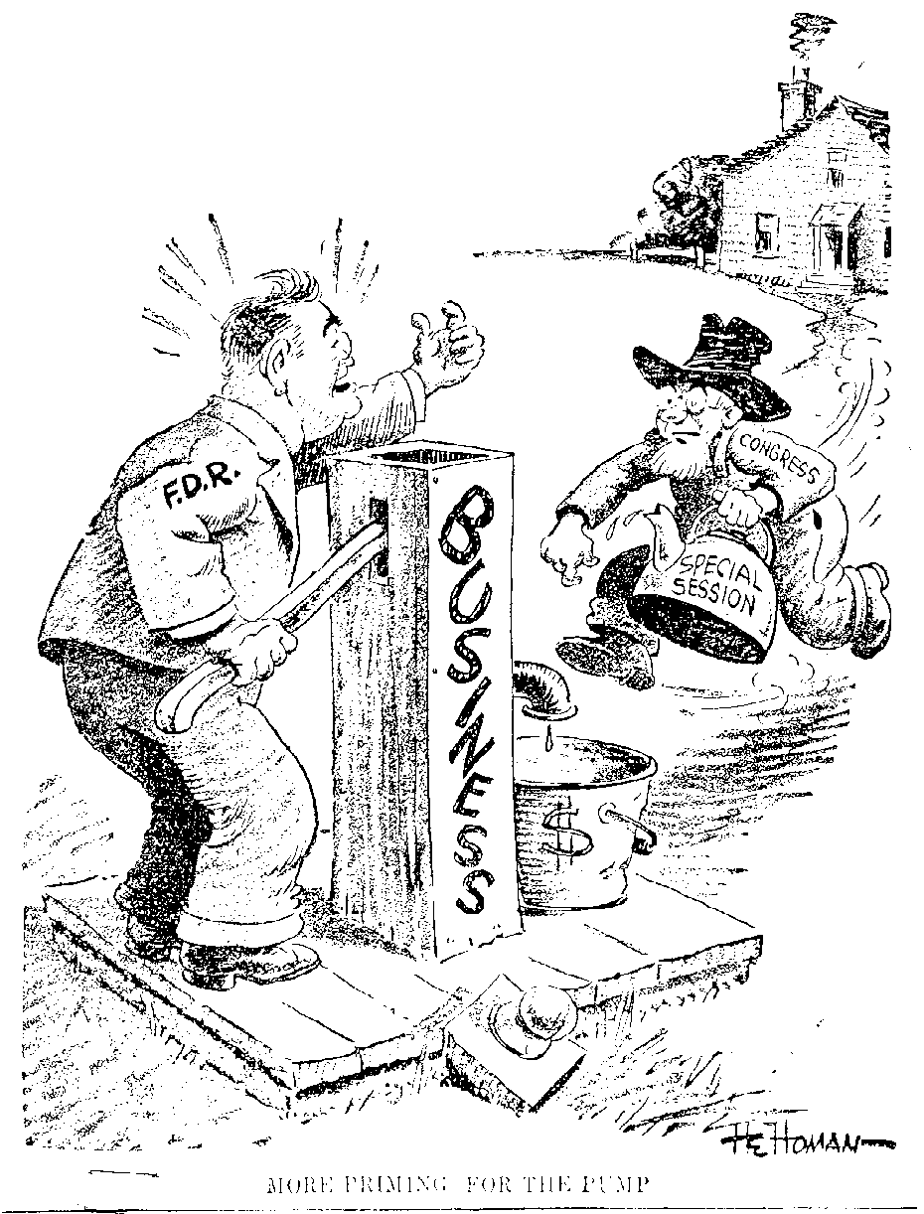

The best person to be president is__________________________________ because he believes a solution to the Great Depression is _____________________________________________________________________. This is a good idea because ____________________________________________________________________. In contrast, I would not vote for __________________ because he believes that ____________________________ _______________________________________________________. This is a bad idea to relieve the United States from the Great Depression because _______________________________________________________________
____________________________________________________________________________________________.

