Edward R. Murrow High School Ms. Sarno & Ms. Albu
#4
Allen Barge, Principal American History Semester 2

The Great Migration
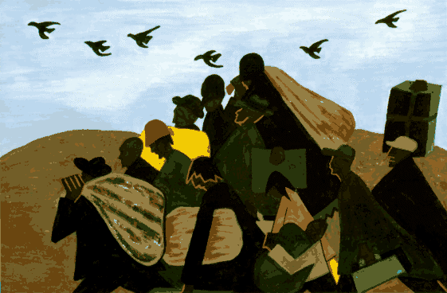
I. Introduction
The Great Migration was the movement of 6 million blacks out of the Southern United States to the Northeast, Midwest, and West from 1910 to 1970. The First World War created a labor shortage in the United States by ending the mass immigration of Europeans workers who provided much of the labor to power American industry. Meanwhile, industrialists (big business men) were making money from the war, because America's closest allies, Great Britain and France, relied on the United States for supplies. To end the labor shortage, the industrialists encouraged white women, black men and women, and Mexicans to enter industrial occupations that they had been barred from before the war. Tens of thousands of black southerners traveled to the North for work.

Directions: Read through the experiences of African Americans migration from the south to the north. Use the information from the documents to fill in the blanks.

Q. To what extent were northern cities a “land of hope” for blacks southern migrants?

African Americans left the South because they faced many challenges. One challenge African Americans faced was____________________________________________________________________________________
Another challenge African Americans faced in the South was __________________________________________
_____________________________________________________________. During WWI, more factories in the North needed workers because _________________________________________________________________
____________________________________________. This inspired African Americans in the South to ____________________________.
When they arrived in the North, one challenge African Americans faced was ________________________
_____________________________________________________.Another challenge that they faced in the North was________________________________________________________________________________________
___________________________________________________. On the other hand, African Americans saw the North as a land of hope because _________________________________________________________________
_________________________________________________and _______________________________________
___________________________________________________________________________________________.
From the information above, the North was/was not (circle one) a land of hope for African Americans. Even though African Americans experienced _____________________________________________________________
____________________________________________________________________________________; however, African American lives improved/did not improve (circle one) because __________________________________
____________________________________________________________________________________________
__________________________________________________. This shows that life was worse/better/
much better (circle one) in the North because _____________________________________________________
____ _________________________________________________________.

