Edward R. Murrow High School Ms. Sarno & Ms. Albu

**#15**

Allen Barge, Principal American History Semester 2

**WWII—Atomic Bomb**

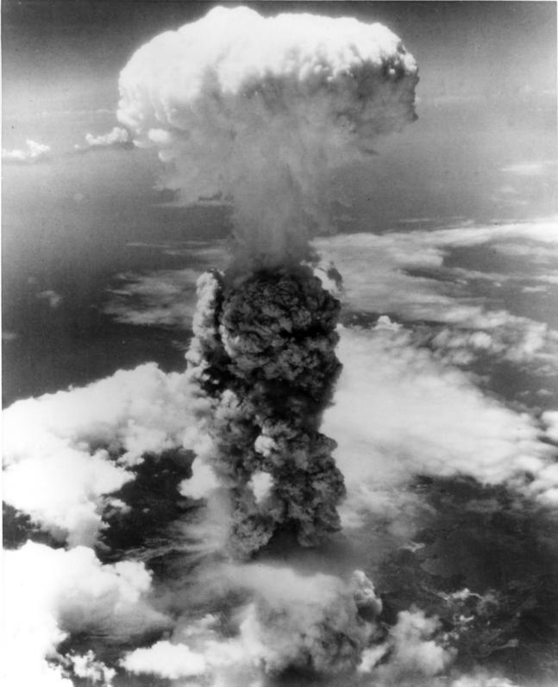

**I. Introduction**

America joined WWII in 1941. By 1944, most of the Axis powers surrendered. However, in 1945, WWII was not over. The Japanese continued to fight. Also, FDR died and Vice-President **Harry S. Truman** became the president of the U.S. During this time, the U.S. was already working on creating an atomic bomb. Now that the bomb was created, the decision was whether or not a bomb of such strength should be dropped on Japan to end the war. President Truman agreed to drop the bomb. On August 6, 1945, the first atomic bomb was dropped on the Japanese city **Hiroshima**, but there was no reply from the Japanese. On August 9, a second bomb was dropped on Japanese naval base of **Nagasaki.** Finally, on August 9, 1945, the Japanese surrendered. Later when Truman was asked about his decision, he answered, **“I wanted to save a half of a million boys on our side… I never lost sleep over my decision.”**

**DIRECTIONS: There has been much debate whether or not the U.S. should have dropped the Atomic Bomb on Japan. Read through the different opinions below and evaluate if the U.S. should or should not have dropped the atomic bomb. Fill in the template below with your response using supporting details.**

|  |  |
| --- | --- |
| **Reasons to Drop the Bomb** | **Reasons NOT to Drop the bomb** |
| **1. The need to end the war quickly with minimum loss of American lives.**  Military advisors to Truman believed that it might take another year to conquer Japan with a land invasion and that would cost a lot to keep fight. It was guessed that the loss 500,000 to 1 million Americans lives would be lost if the U.S. continued to fight. Too many U.S. lives were lost in battle. | **1. Not Necessary to Save American Lives**  The Japanese military and navy were very weak and damaged by the summer of 1945. The U.S. did not need to send more troops to Japan to fight because the Japanese were about to surrender by the Fall of 1945. (The Japanese government had even stated that they would surrender as long as they could keep their Emperor.) |
| **2. Economically ($) practical**  Billions of dollars went into developing the bomb, along with the manpower of the nation’s leading scientists. If the country spends so much to produce the weapon, it should be used. Dropping the bomb will end the war faster and if we can end the war as quickly as possible, the U.S. will spend less money. | **2. Tremendous cost in human life**  It is estimated that almost 200,000 Japanese civilians died instantly in the bombing of Hiroshima and Nagasaki. Over 100,000 Japanese died from radiation exposure over the coming years. Other effects were hair loss, nausea (vomiting), bleeding from the mouth, gums, and throat, weakened immune systems, internal bleeding, radiation burns, and/or killed or permanently damaged fetuses in the womb. |
| **3. Japan had been nothing but aggressive (forceful)**  Many Americans hated the Japanese because of their wartime behavior. Americans viewed the Japanese as animals, not as people. It was believed that dropping the bomb was justified (acceptable) because of Japanese aggression. | **3. Racism**  The Japanese life was not valued. Americans viewed the Japanese as an inferior (lesser) race of beings. Truman had public support to use the bomb on the Japanese whereas he would not have had the same support to use it on the Germans or Italians. |
| **4. Don’t let the Soviet Union get too big**  President Truman feared that the Soviets would have too much say in the Far East when the war was over. Communism was spreading and the United States did not like this at all. Even though the U.S. and Soviet Union were allies during WWII, by dropping the bomb, the U.S. was able to threaten the USSR by showing it was more powerful. | **4. Origins (Beginning) of the Cold War**  The use of the bomb was meant to threaten the Soviets. The U.S. being unfriendly to the Soviets in the Far East will cause distrust, anger, and competition to develop after the war. |
| **5. Factories making weapons**  Both the cities of Hiroshima and Nagasaki were large industrial cities. In both of these cities were large manufacturing plants where weapons were made. It was important to wipe out these targets. | **5. Killed innocent people (civilians)**  As the plan was developed, the Atomic Bomb was to be dropped on a very populated area, which killed many civilians. Even if the U.S. planned to use the bomb in order to show power, there was no need to drop the atomic bomb in a city and kill innocent civilians. |

The United States **should/should not (circle one)** drop the atomic bomb on Japan. The U.S. **should/should not (circle one)** drop the bomb because ______________________________________________ and ______________________________________________________. Even though **not dropping the atomic bomb/dropping the atomic bomb (circle opposite of your argument)** is a good reason because _____________

_______________________________________ and _________________________________________________, it is better to **drop the atomic bomb/not drop the atomic bomb (circle one that agrees with your argument)** because ____________________________________________________________and ______________________

_________________________________________. As a result, if the U.S. does **drop the atomic bomb/does not drop the atomic bomb (circle one that agrees with your argument)** it will be better because ________________

_____________________________________________________ and ___________________________________

____________________________________________________________________________________________.