EDWARD R. MURROW HIGH SCHOOL SOCIAL STUDIES DEPARTMENT
MR. Barge, PRINCIPAL Ms. Albu & Ms. Sarno

American History HOMEWORK Packet Part 1 – Semester 1
Directions:
- All homework will be collected and checked throughout the semester. All assigned homework assignments will be posted on the board in the beginning of class.
- All homework assignments must have your name, the band and the homework number written at the top of the paper.
- You do not need a textbook to complete your homework. All information is provided in this packet.
- A minimum of ten assignments will be graded on a scale of 1-3 (3 being the highest grade possible). If you receive a score of a 1 that means you have not completed your assignment and you have a chance to redo the assignment for a better grade.
- You are responsible for making sure that that your homework is handed in on time. If you are absent, it is your responsibility to make sure that you make up your homework assignment and hand it in.
- One sentence answers are not acceptable, nor are incomplete assignments, lists, charts. All answers need to be complete and thorough. All of your answers MUST be in your own words.
- Finally, please remove all trim from your homework. Meaning if you write in a spiral notebook please remove the excess fringe on the edge before handing in your homework.
Homework #1 Migration to the New World
Why People Came to the New World
A long, long, time ago, only Native Americans lived in what is now known as the United States and Canada. At first the Europeans came to the New World to explore and visit. Each time these visitors returned home, they told everyone about the wonderful things that could be found in the New World, “America”. There were lots of forests, animals, water, and rich farmland. Soon people from other countries wanted to live in America. When a country builds a settlement beyond its borders, it is called a colony. People from Spain were the first Europeans to build a colony in America – they settled around the Southern areas like current day Mexico and South America (that's why they speak Spanish there).
In 1620, a group called Separatists came to the New World. They were avoiding religious persecution in England. Today we refer to them as Pilgrims. A pilgrim is a person who makes a journey for religious reasons. This colony was called Plymouth. Many pilgrims died during the first year. An Indian named Squanto, and other Indians helped the pilgrims to survive. To thank God and the Indians, the Pilgrims held a celebration in the fall of 1621, the feast, was the very first Thanksgiving.
In 1629, another religious group called the Puritans came to the New World. They were also seeking religious freedom. They wanted to establish a place that would set an example of how God wanted people to live. Many died coming to the New World. Many died while trying to survive in the New World. So why did people come to America?
One reason was that in European countries the first-born son inherited all of the fathers land. Some of the younger sons then came to America to get their land. Another reason had to do with religion. In England people had to worship like the King ordered them to. People came to America so they could worship in their own way. Some people were brought to the colonies against their will. Black slaves were brought from Africa to Virginia. Eventually there were black slaves in all of the thirteen colonies, but most of them lived in the South. Some English people came to bring Christianity to the Native Americans. Others came because they thought America was filled with jewels and gold! Many others came for the adventure of it all and the excitement of living in a faraway land! The colonists came to America for many reasons. But they had one thing in common. They wanted the freedom to live the way they thought best.
HOMEWORK #1 QUESTIONS:
- Which European countries came to the “New World?”
- What are five different reasons that Europeans came to the new world?
- Considering what North America was like in the 1600's (forests, Native Americans, farming, no traditional houses, a long boat ride) how would you have reacted to the opportunity to travel to America? What challenges would you have to confront? (Minimum 3 sentences)
Manufactured Goods
These are products that have been made by machines and are ready to be sold to people. Example: A pair of sneakers
Raw Materials
These are the materials that are used to build other products. Example: Rubber and leather (both are used to make sneakers)
Homework #2 Road to Revolution – British Taxation
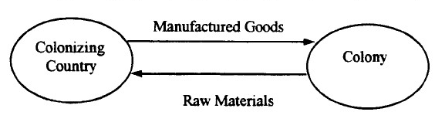

The 13 Colonies
England

Stamp Act (1765)
The Stamp Act “required all legal documents, permits, commercial contracts, diplomas, newspapers, wills, pamphlets, and playing cards [used or written by the colonists] … to carry a tax stamp. The Stamp Act was created in order to pay for the cost of maintaining the [British] military presence protecting the colonies.”

CONTINUE HW #2 ON NEXT PAGE →

Benjamin Franklin’s Opinion of the Stamp Act
Benjamin Franklin’s Pennsylvania Gazette first reported a “Scheme of Taxation of the American Colonies” in its May 10, 1764 issue:

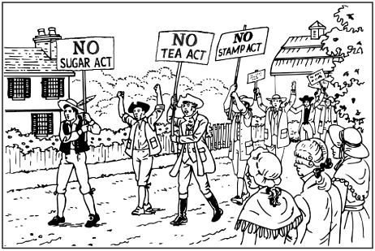
Colonists can NOT be a part of British Parliament
No Representation in Parliament is not fair!
We should have a say about taxes!
We need the Stamp Act to pay for our soldiers.

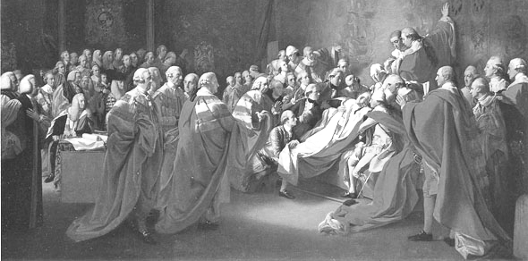


HOMEWORK #2 QUESTIONS:
- Using the diagram on the previous page, explain the relationship between the Mother Country (England) and its colonies.
Read the Stamp Act, Benjamin Franklins Opinion of the Stamp Act and the images above in order to answer the following questions.
- What was the Stamp Act?
- Why did the colonists feel the British taxes were unfair?

Homework #3 Road to Revolution and the Declaration of Independence

“…I offer nothing more than simple facts, plain arguments and common sense…It is right and reasonable for America to separate from England…If we stay with England we stay connected to England, we will get too involved in British political problems…Even the distance between England and America gives proof that we are not supposed to be connected…The period of debate is over. Weapons must be used as a last resort and they will decide who wins the argument…”
- Thomas Paine “Common Sense”

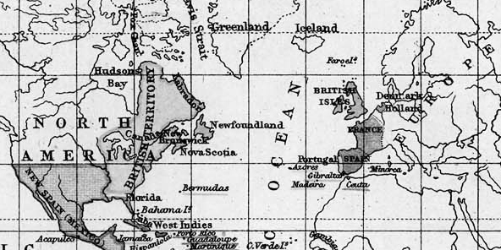
13 Colonies
ENGLAND

In the late 1700’s it would take you anywhere from 4 to 9 weeks to travel from the Colonies to England

HOMEWORK #3 QUESTIONS:
- Describe why Thomas Paine believes that it is “common sense” to declare independence (common sense is kind of like saying “Duh!” Why is it true for him that “DUH! We SHOULD separate from England)?
Based on the above information AND classroom discussions:
- Would you support the creation of a declaration of independence? What would you include in it? Provide 2 reasons to support your answer.

Homework #4 Thematic Essay Homework – Day 1
Use the notes and worksheets from your class lesson in order to write your essay.

Below you will find a Thematic Essay question. Read the Historical Context and Essay Task carefully and then create an introduction paragraph as if you were writing this essay. Please note – you are not writing the entire essay, just the introduction paragraph with thesis.

    - Underline the thesis statement in your introduction paragraph.

Historical Context
By 1776, the American colonists found themselves locked in a bitter conflict with England. To this day, the reasons behind this transition from allies to enemies are debated.

ESSAY TASK:
Were the colonists justified in declaring their independence from Britain?

*** There are 2 key words in the essay task that you may need to look up in your notes or dictionary***

Homework #5 Regents Questions about Early Colonial Life
Read the text below to guide you in answering the multiple choice questions.

Many other explorers came before him, but Columbus landing in the Caribbean in 1492 was very important because his travel led to the colonization of the New World (North, Central, and South America) by European countries. England’s greatest possession was its 13 colonies along the East Coast of North America (what is now present-day United States), these were known as The American Colonies. The Mother Countries get rich from colonization because they would take natural resources from the land, sell their products and collect taxes from their colonists. The economic system they created was known as mercantilism.

The America colonists slowly began to form early steps of self-government and early representative democracies (governments based on the people—consent of the governed). The Mayflower compact, New England town meetings, and the Virginia House of Burgesses are early examples of democratic practices in early American history. The British policy of Salutary Neglect, being left alone by Britain, allowed for the growth of democratic government. At this time there was movement called the Enlightenment where many great thinkers began to question things like human rights and the role of government. The ideas of philosophers like John Locke, and John Jacques Rousseau greatly affected the way people viewed Britain’s control over her 13 American colonies – the relationship between the two was about to be strained!

All of this tension, including Enlightenment ideas such as Thomas Paine’s pamphlet “Common Sense” led the colonists to write The Declaration of Independence and fight the American Revolution.

1. The British system of mercantilism was opposed by many American colonists because it
A. placed quotas on immigration
B. discouraged the export of raw materials to England
C. placed restrictions on trading
D. encouraged colonial manufacturing

2. Which fundamental political idea is expressed in the Declaration of Independence?
A. The government should guarantee every citizen economic security.
B. The central government and state governments should have equal power.
C. If the government denies its people certain basic rights, that government can be overthrown.
D. Rulers derive their right to govern from God and are therefore bound to govern in the nation’s best interest.

3.During the Revolutionary War period, Thomas Paine’s Common Sense was important because it
A. described a military plan for the defeat of England
B. convinced many Americans who had been undecided to support independence
C. contained a detailed outline for a new form of government
D. argued for the addition of a bill of rights to the Constitution

4. The Mayflower Compact and the House of Burgesses were important to the development of democracy in colonial America because they
A. expanded freedom of religion
B. promoted self-government
C. protected private ownership of property
D. granted voting rights to all white males

Homework #6 Articles of Confederation

Articles of Confederation - Powers of the Federal Government
- Make war and peace.
- Send and receive ambassadors.
- Enter into treaties.
- Borrow money.
- Raise and equip a navy.
- Maintain an army by requesting troops from the States.
- Request (not require) funds from the States to meet the costs of government.
- Regulate Indian affairs.
- Figured out a way to add new states to the country
- Establish post offices.

Weaknesses of the Articles
- No national executive
- No national court system
- National government could not collect taxes
(no money to build strong army or pay the president)
- National government could not raise an army
- National government could not regulate trade
- Currency Problems: Many states printed their own money.
The national currency, meanwhile, became almost worthless
- State governments had more power then the Federal Government

CONTINUE HW #6 ON NEXT PAGE→

HOMEWORK #6 QUESTIONS:
- Looking at the main ideas of the Articles of Confederation, Describe AND Explain 3 positive elements (parts) of the documents.
- What changes should be made to make this document more effective (helpful) to the United States?

Homework #7 Constitutional Convention

Within five days of meeting in Philadelphia, Pennsylvania in May 1787, the 55 delegates at the Constitutional Convention gave up on the idea of fixing the Articles of Confederation. In the following four months they debated over the form of a new government known as the Constitution.

An immediate issue facing the delegates was how to give fair representation to both large and small states. Political leader James Madison (also known as the “Father of the Constitution”) offered the Virginia Plan. The Virginia plan said that a state’s representation should be based on the size of its population. Under this plan, the larger state, the more political power it would have. The smaller states objected to (were against) this plan. Smaller states supported the New Jersey Plan. The New Jersey plan called for giving each state equal representation – no matter what size.

The delegates finally settled on a compromise, a plan developed by delegate Roger Sherman. His plan became known as the Great Compromise. It called for a legislature (Congress – piece of government with representatives chosen by the people) with two houses (parts) – a House of Representatives and a Senate. Each state would have two members in the Senate. In the House, the number of representatives from each state would be based on the size of the state’s population.

The delegates then debated whether slaves should be included in a state’s population. The northern states had very few slaves. As a result, they did not want slaves counted towards a state’s representation in the House of Representatives. The southern states, which had a lot of slaves, favored counting slaves into a state’s population, thus giving them more power in Congress. The delegates again came to a compromise. Their agreement was known as the Three-Fifths Compromise. It allowed each state to count three-fifths of their slaves as part of the population.

HOMEWORK #8 QUESTIONS:
- What is a compromise?
- How did the Great Compromise satisfy both small states and large states?
- Describe the Three-Fifths Compromise?
- In your opinion, which was more important in 1787, maintaining slavery or creating national unity?

Homework #9 Constitution – Federalism

In America we have two governments. One is a government for the WHOLE country in Washington DC. The other government we have is in each STATE. So New York State makes some of it's laws, and Washington DC makes some of the other laws for the country. The government in Washington DC (with the president and the congress) is known as the FEDERAL government. It's like Mr. Barge – it's in charge of the WHOLE school. The smaller government is known as the STATE government (kind of like Ms. Sarno and Ms. Albu, we are only in charge of our classroom. We can make rooms for our classroom but not for the WHOLE school – only Mr. Barge can do that. The U.S. Government is the same way.

“…It is difficult for the federal government to guarantee all rights of each independent state, and at the same time to have a federal government that provides for the interest and safety of the union of states. Individual states entering into a union must give up some of their rights and liberties (freedoms) to keep the rest protected by the federal government. We must make sacrifices to reach our goals as a nation. We promise that the power under the Constitution will always be in the people…”
  - George Washington, President of the Constitutional Convention (adapted)

HOMEWORK #9 QUESTION
- According to Washington and the description above him, explain what the relationship between the Federal Government and the States should be.

Homework #10 Constitution – Checks and Balances – (4 questions total)

U.S. Constitution: Separation of Powers and Checks and Balances
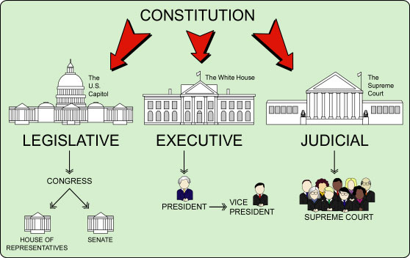
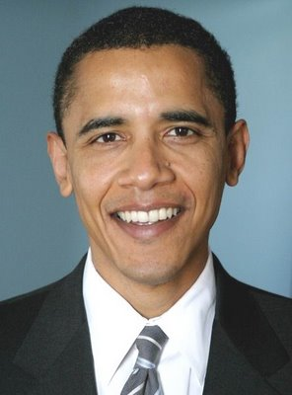
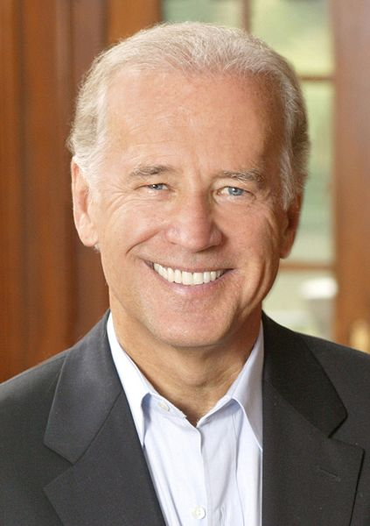
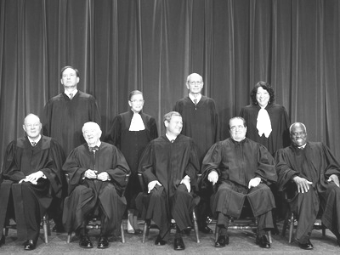
Branches of the U.S. Government
CONTINUE HW #10 ON NEXT PAGE →

HOMEWORK #10 QUESTIONS:
- Based on the diagram above, describe what the term “separation of powers” means in American government.
- Using the diagram above, explain why you think the separation of powers is necessary.

HOMEWORK #10 QUESTIONS :
The separation of powers leads to a system of checks and balances in the government. Read the scenario below about one branch checking the power of another and answer the questions based on it.

Michael Jackson returns from years in hiding with a new album, all part of his plan to make a memorable comeback. He is taken to the Federal court for faking his death and is sentenced to 6 months in jail and 3 years community service. The President has decided to step in and pardon Jackson because he is a huge fan of his music.”
- Which branches of government are involved in this scenario?
- Which branch is exercising its power to check another?

Homework #11 Electoral College
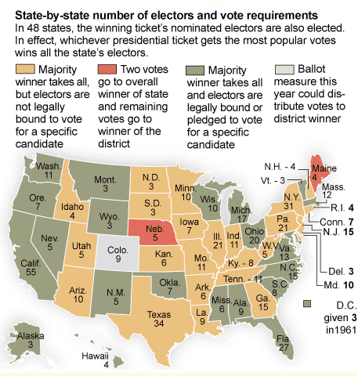

HOMEWORK #11 QUESTION

MAKING VOTES COUNT

MAKING VOTES COUNT; Abolish the Electoral College

Published: August 29, 2004
The Electoral College got a brief moment of attention in 2000, when George Bush became president even though he lost the popular vote to Al Gore by more than 500,000 votes. Many people realized then for the first time that we have a system in which the president is chosen not by the voters themselves, but by 538 electors. It's a ridiculous setup, which thwarts the will of the majority, distorts presidential campaigning and has the potential to produce a true crisis. …

The main problem with the Electoral College is that it builds into every election the possibility, which has been a reality three times since the Civil War, that the president will be a candidate who lost the popular vote. This shocks people in other nations who have been taught to look upon the United States as the world's oldest democracy. The Electoral College also heavily favors small states. The fact that every one gets three automatic electors -- one for each senator and a House member -- means states that by population might be entitled to only one or two electoral votes wind up with three, four or five.

NEW YORK TImES ARTICLE EXERPT – oP-eD Pages

http://www.nytimes.com/2004/08/29/opinion/making-votes-count-abolish-the-electoral-college.html (Accesses 8/15/2010)

- Based on the information above, (the diagram and NY Times Op-Ed Article) explain fully two problems with the way we elect the president?
Homework #12 Federalist and Anti-Federalist
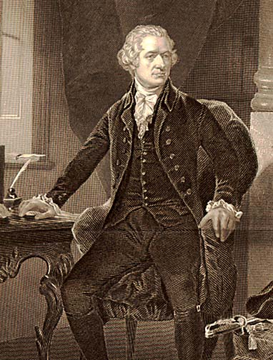
“The reasons for a united government are simple: A strong Federal Government is important for the defense of all states; to keep peace from problems outside and inside the country; to control trade with other nations and between states; to organize relationships with other countries…These powers should exist without any limits on power because you just never know what emergencies the nation is going to face.”
- Alexander Hamilton (1788)

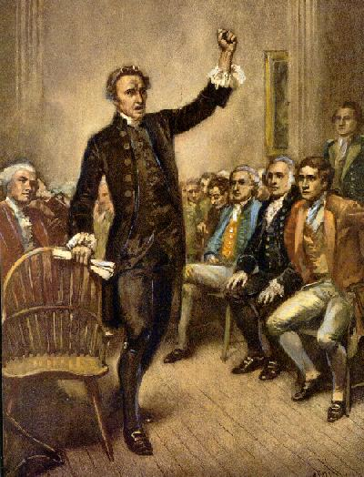
“The constitution is supposed to have great strengths, but when I look at it, I see problems. This government could become a monarchy. The president could easily become a king. The way the senate is elected and organized could lead a small group to taking away the rights and power of all the people.”
- Patrick Henry of Virginia
– Patrick Henry of Virginia (1788)

HOMEWORK #12 TASK
- Based on the quotes above complete the chart below on a separate sheet of paper and fill in two examples of what each side believes the role of the Federal Government should be.

Differences between Federalists and Anti-Federalists
Federalists  want a strong federal government  (Alexander Hamilton) | Anti-Federalists  want a weak federal government / stronger state government  (Patrick Henry)
1. | 1.
2. | 2.

Homework #13 President Adams and the Alien and Sedition Acts (1798)

Alien Act:
“Whenever there is a declared war between the United States and any foreign nation or government, or any invasion attempted against the territory of the United States, all natives, citizens, or subjects of the enemy nation living within the United States,
who have not been given U.S. citizenship can be arrested, restrained and removed from the U.S. as alien enemies.”
- approved by Congress July 6, 1798

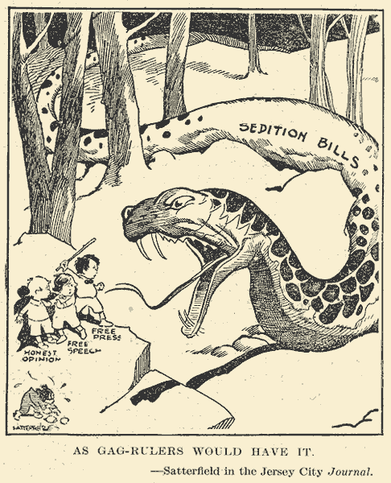
Sedition Act:
“If any person writes, speaks or publishes scandalous and mean words against the government of the United Stated, or the President of the United States, with the intention to damage the name of the government, or to start any hatred against the country, or to create sedition (rebellion) within the United States…then the person will be punished by a fine and by imprisonment (jail).
- approved by Congress July 14, 179

HOMEWORK #13 QUESTIONS
1. Describe in your own words the meaning of the Alien Act.
2. Describe in your own words the meaning of the Sedition Act.
3. Do you think these acts are necessary in today’s world?
Explain your answer.

Homework #14 President Jefferson

“…We will unite in common efforts for the common good. All of us will keep in mind this idea, that though the will of the majority will always win, the minority has their equal rights and should be protected. We must have an equal law to protect the minority and to violate this would be oppression. Let us, then, fellow citizens, unite with one heart and one mind…Equal and exact justice to all men, of whatever state or persuasion, religious or political; peace, commerce, and honest friendship with all nations, entangling alliances with none.”
- Thomas Jefferson, Inaugural Address

HOMEWORK #14 QUESTIONS
- Based on the quote above from Jefferson, how does Jefferson want his administration to act and provide the citizens of the United States?
- Do you feel that Jefferson would be happy with the actions of politicians today? Why or Why not? Do we let all people have a voice?
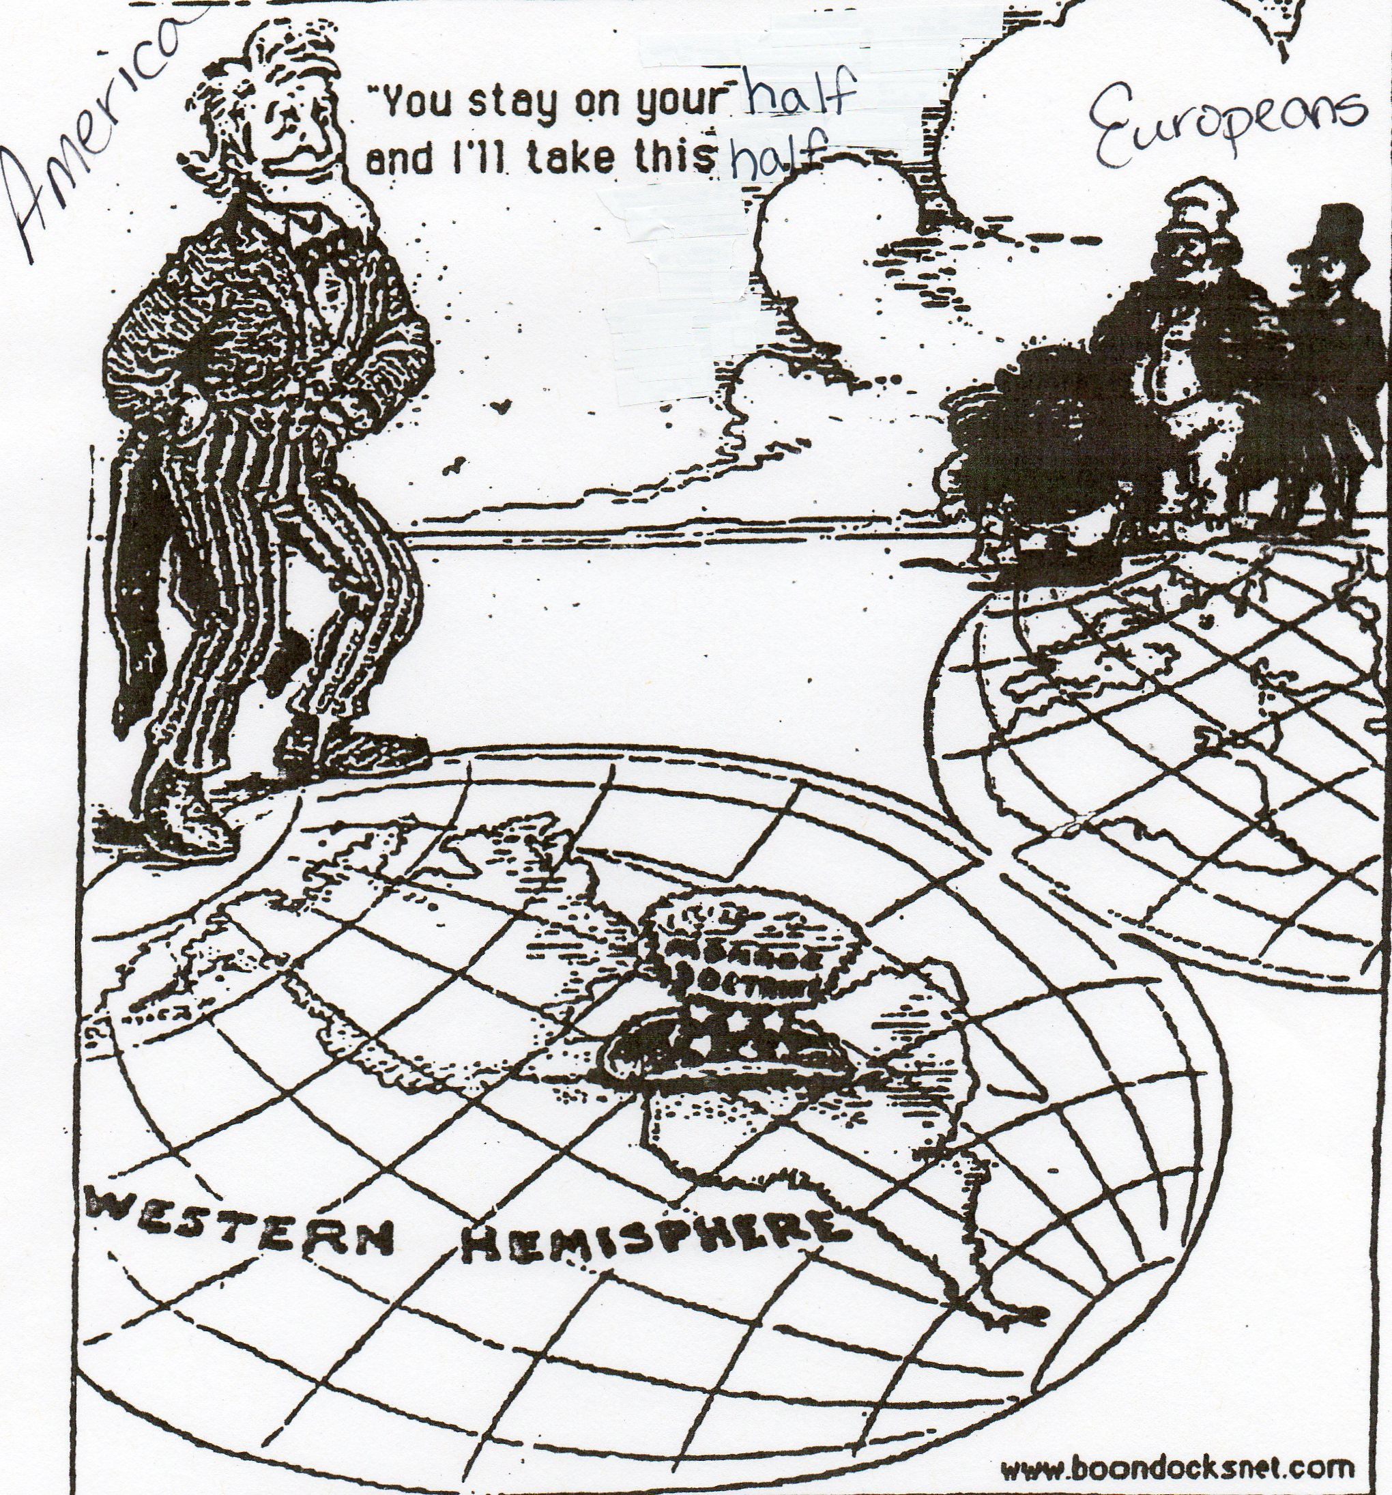
Homework #15 Monroe Doctrine

HOMEWORK #15 QUESTIONS

1. Describe what you see in the cartoon.

2. What is the main idea of this cartoon?

3. What title would you give this cartoon?

Homework #16 Andrew Jackson
“There are very few people who can hold a public office for a long period of time without forgetting that their true job is to work for the public. People who hold their jobs for a long time tend to lose interest in what the public wants or needs. I believe that more damage is caused by keeping men in jobs for long periods of time than benefits are gained by their longer experience.” – Andrew Jackson

“Ignorant, passionate, hypocritical, corrupt, and easily swayed by the low men who surround him”
- Henry Clay

“A man of intelligence…one of those prompt, frank, ardent souls whom I love to meet.”
- Aaron Burr

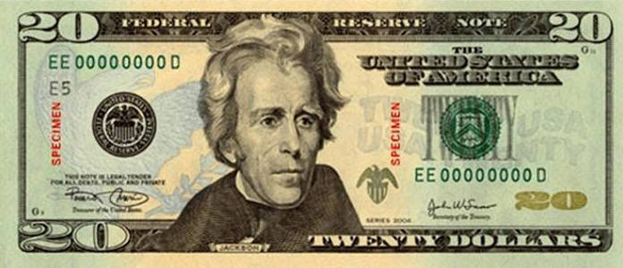
“A barbarian who could not write a sentence of grammar and hardly could spell his own name.” - John Quincy Adam

“I never knew a man more free from pride…”
– Martin Van Buren

"The national policy, pursued by [my] Government is for the removal of the Indian tribes originally settled on this side of the Mississippi ...." -- Andrew Jackson

HOMEWORK #16 QUESTIONS
- Based on the above quotes do you think Andrew should be the face of the $20 bill? Why or why not? Give at least two reasons to support your answer.

Homework #17 The Issue of Slavery
“More than twenty years of my life were taken from me in a state of slavery…The law gives the master absolute power over the slave. He may whip him, hire him out, sell him, and in certain circumstances, kill him without being punished for it. The slave is a human being, stripped of all rights – considered property in the eyes of the law…He can own nothing and buy nothing. To eat the fruit of his own work, to clothe himself with the work of his own hands, is considered stealing. He works so that someone else may take the profit of his labor…a slave rests on the cold, damp ground, so that another man can sleep on the softest pillow…”
– Frederick Douglass (Dec. 1, 1850)

HOMEWORK #17 QUESTIONS
- How does Frederick Douglass describe the institution of slavery?
- Why might Frederick Douglass be a great leader in the struggle to end slavery?

