Poets and Writers of the Harlem Renaissance

Langston Hughes

“If white people are pleased we are glad. If they are not, it doesn’t matter…if colored people are pleased we are glad. If they are not, their displeasure (unhappiness) doesn’t matter either. We build our temples for tomorrow, strong as we know how, and stand on top of the mountain, free within ourselves.”

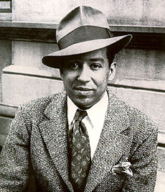
I, too, sing America.

I am the darker brother.
They send me to eat in the kitchen
When company comes,
But I laugh,
And eat well,
And grow strong.

Tomorrow,
I'll be at the table
When company comes.
Nobody'll dare
Say to me,
"Eat in the kitchen,"
Then.

Besides,
They'll see how beautiful I am
And be ashamed—

I, too, am America.

Questions:

1. How does Langston Hughes describe how African Americans are treated?

2. How does Langston Hughes hope African American will be treated in the future?

3. Why do you think Langston Hughes needs to say that he is America?

