The Elderly and African Americans

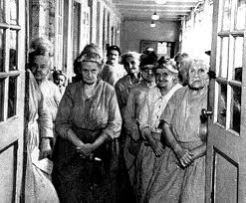
There were no services for the aging of America. They were out of work and out of money. The government did not provide for the needs of those who could not provide for themselves. The elderly did not have retirement funds to take care for them in their later years. People were also living longer and were not prepared for their older years. The elderly were also not getting hired for jobs.

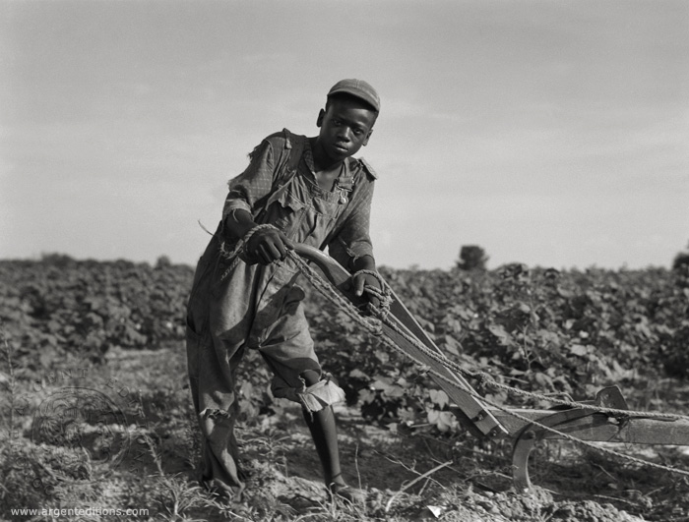
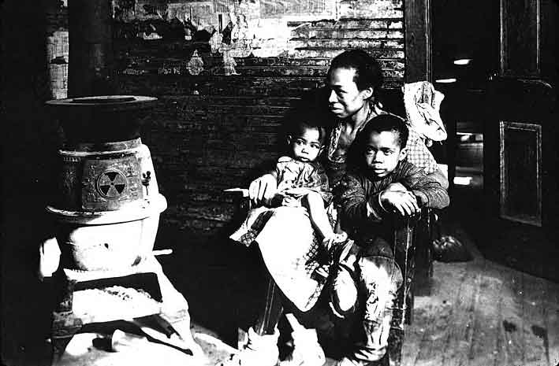
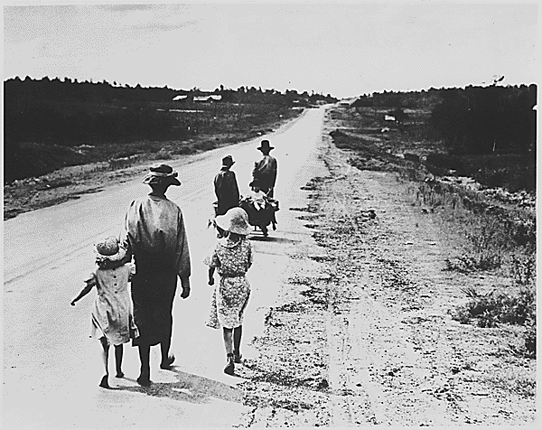
Although the suffering of the 1930’s was severe for many people, it was especially harsh for African Americans. Many blacks already experienced hard times in the U.S., as one African American man notes, “The negro was born in depression. It didn’t mean too much to him, the Great American Depression…the best he would be is a janitor or a porter (caretaker) or a shoeshine boy. It only became official when it hit the white man.” Nonetheless, the African American community was hit hard by the Great Depression. In 1932, the unemployment rate among African Americans stood at over 50%, while the overall unemployment rate was about 25%.
Unemployment
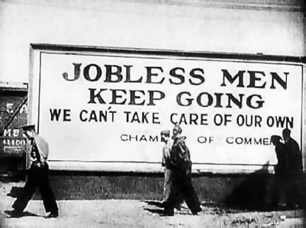

“Brother, Can You Spare a Dime?”
Song by E.Y. Harburg and J. Gorney, 1930

They used to tell me that I was building a dream
And I followed the mob.
When there was earth to plow or guns to bear
I was always there—right on the job.

They used to tell me I was building a dream
With peace and glory ahead.
Why should I be standing in line
Just waiting for bread?
Results of Drastic Deflation (Decrease in normal cost of a good or service)

Here are some prices advertised by a market in Los Angeles on September 6, 1932:

Bread, loaf - $.05
Lettuce, per head- $.01
Spring Lamb Chops, per pound- $.12
Choice Sirloin Steak, per pound - $.20
Tomatoes, 8lbs - $.05
Sliced Bacon, per pound $.10

Once I built a railroad, made it run
Made it race against time
Once I built a railroad—now it’s done.
Brother, can you spare me a dime?

Once I built a tower to the sun,
Brick and rivet and lime.
Once I built a tower—now it’s done.
Brother, can you spare a dime?

Children
Dear Mrs. Roosevelt,

I am writing this letter in the hope that you will answer in my favor. My father H.C. had been in bed from a stroke for almost a year. We have no money and my brother works, but make $3.00 a week and there are eight in our family.
My stepmother is very good to me and I try to help her. She takes in washings and I have to walk for six or eight blocks and then carry the washings home. I have to go to school in the morning and it has been very cold here. If you could send me a bicycle to ride when I go after washings for her I shall appreciate it. I am in the eighth grade of school and work very hard to get passing grades. If you would do this for me, I’d be able to help my stepmother more. If you send me one, I would like a girl’s bicycle. I am about 4 feet 3 inches tall, so if you send me one you can judge as to what size.

Loving and appreciating,
A.L.C.
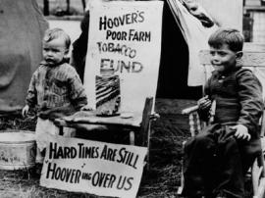
Hoverville Children, 1932
Two small children during the Great Depression sit beside a donation jar labeled “Hoover’s Poor Farm Tobacco Fund.” They are part of a squatter community, of a kind known bitterly as “Hoovervilles” because of the President’s inability to even admit to the existence of a national crisis. A sign in the front reads, “Hard Times are still Hoovering Over Us”. Hoovervilles were homes made of trash by people who lost their homes during the Depression.

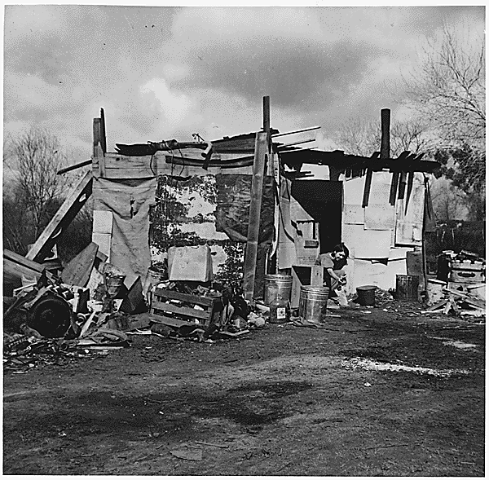

Free Food for the Needy
Breadlines and Soup Kitchens

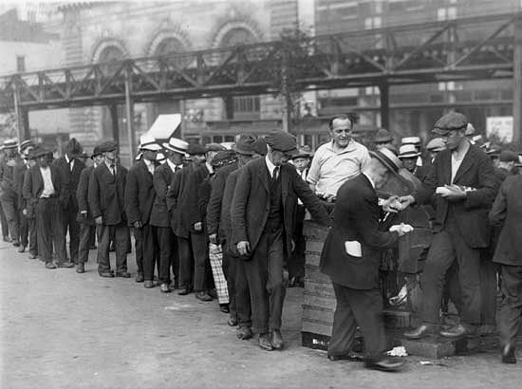
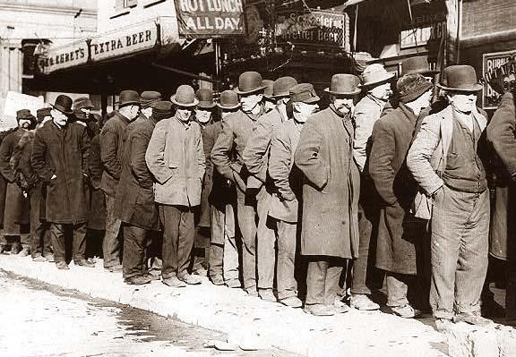

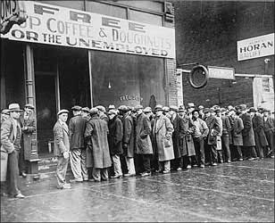
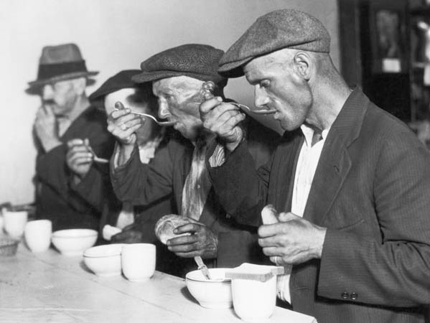
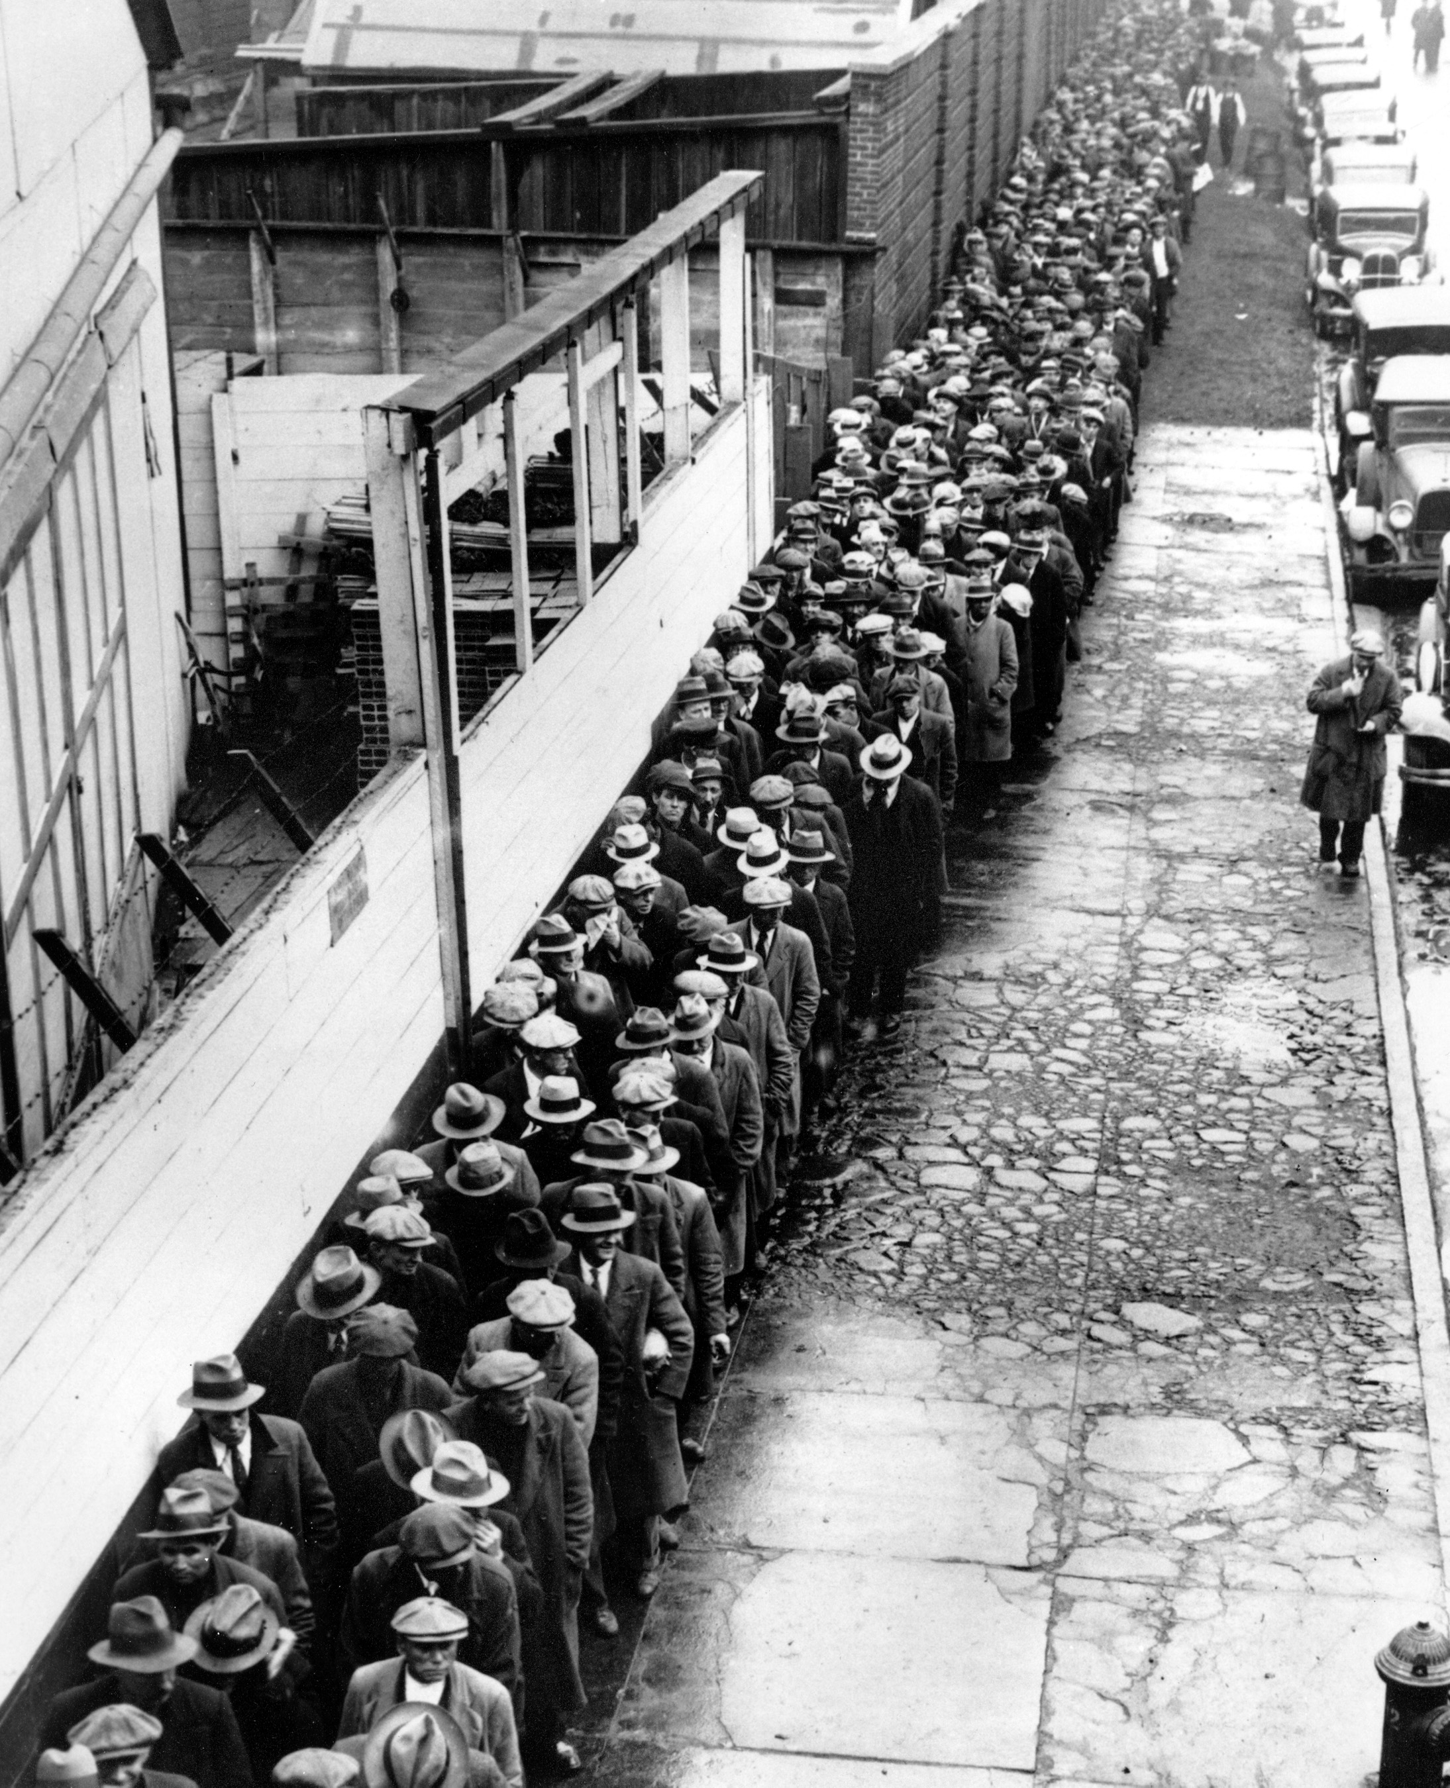
Unemployment Pictures


