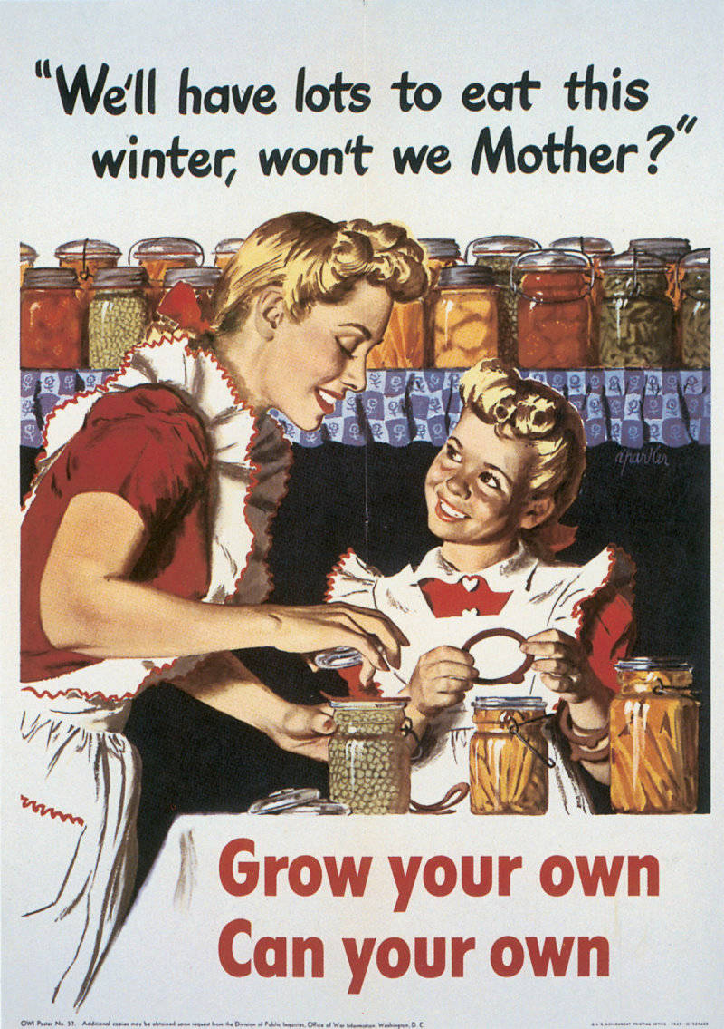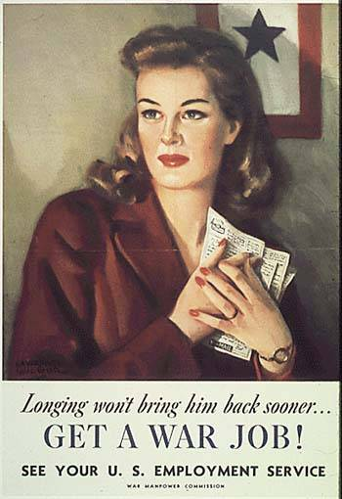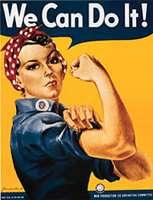**Women in WWII**

During WWII women were expected to be both housewives who did all the chores and work. In this way their jobs were even more difficult as many households did not have modern day conveniences that make cleaning easier. Also the government was rationing (limiting how much people could buy) food—so it was even more difficult to get the needed food to cook basic meals.

Women responded to the demand for help in WWII. Almost 5 million women entered the work force. They replaced the men who joined the armed services. Many women worked in offices. Millions more kept the nation’s factories operating around the clock. Some welded, ran huge cranes, and tended to blast furnaces. Others became bus drivers, police officers, and gas station attendants. The images of Rosie the Riveter, a fictional factory worker, became a symbol of American women’s contribution to the war effort.

**African Americans at War**

[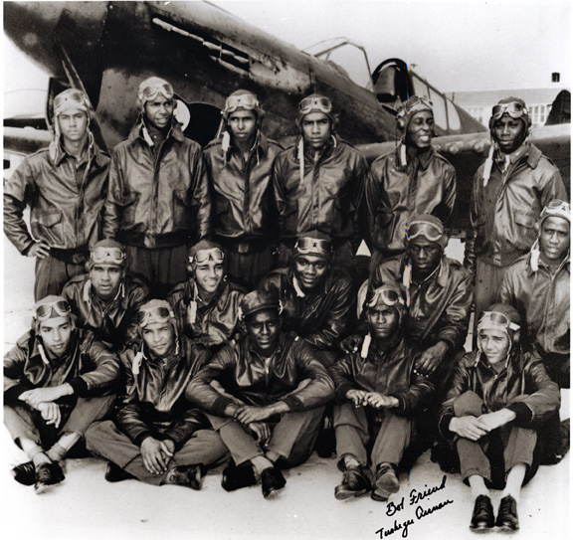](http://www.lloydsstudio.com/Blog/wp-content/uploads/2011/03/Tuskegee-Airm)

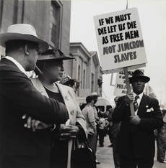  **Mexican Americans**

During WWII, factories replaced “No Help Wanted” signs with **“Help Wanted, White”** signs. Such discrimination angered African Americans. As a result, African Americans protested in from of the White House. Government officials worried. FDR ordered employers that did business with the government to end discrimination in hiring. As a result, the employment of skilled black workers doubled during the war. However, as black employment increased, so did racial tension. Thousands of Americans—black and white—moved to cities to work in industry. Competition for scarce housing led to angry incidents.

The U.S. Air force began a program in Tuskegee, Alabama to train African Americans as military pilots. At the time, the Army was segregated, and only whites were allowed to fly. In the five years that followed, 992 black pilots graduated, receiving commissions and pilot wings. They came from all U.S. cities and wanted to serve their country. These black World War II pilots who fought both fascism and racism became known as **Tuskegee Airmen**.

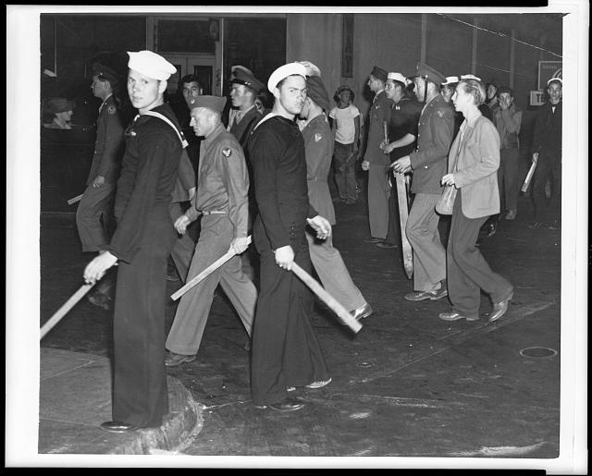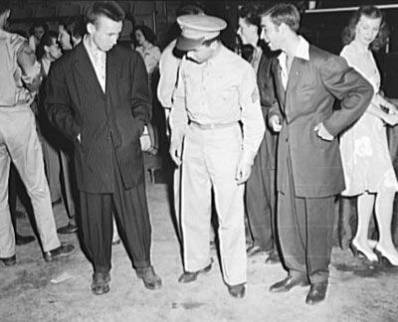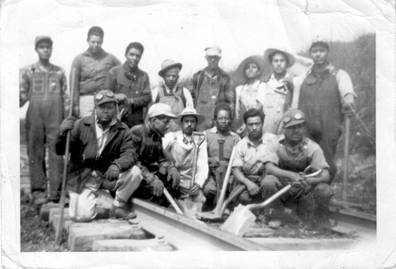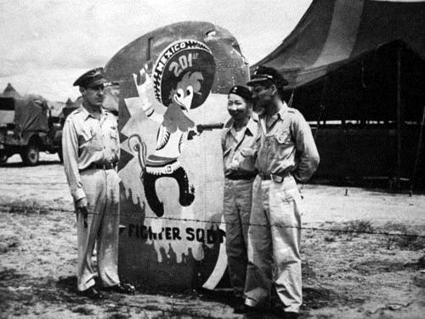

The U.S. was in need for workers. The U.S. signed a treaty with Mexico. It allowed the Mexican to come and work in the United States. Under this **bracero** (Spanish term, meaning manual labor) **program**, many Mexicans moved north to work on farms and railroads.

In 1943, a group of sailors attacked some young Mexican Americans, beating them on the streets. This was due to teens wearing zoot suits (a fashion fad at the time). The incident led to several days of rioting in Los Angeles. Newspapers blamed the violence on the Mexican Americans. Police even left the servicemen alone and arrested the victims instead.

Still, like other groups, Mexican Americans served bravely in the military during World War II. Despite problems, Americans were united in their resolve to push on to victory in Europe and the Pacific.

**Japanese Americans**

**[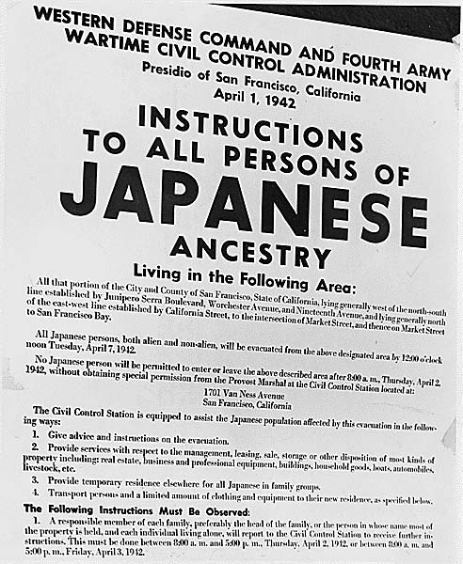](http://peacecorpsonline.org/messages/imagefolder/japaneseinternment.jpg)**

In 1942, FDR signed a law that required all people of Japanese descent—US citizen or not—to be relocated from their homes and moved into internment (prision) camps.

Japanese Americans had to evacuate (leave) their homes, sell all their belongings, and move to unknown territory. They did not know how long they would be staying in the camps.

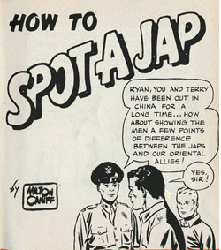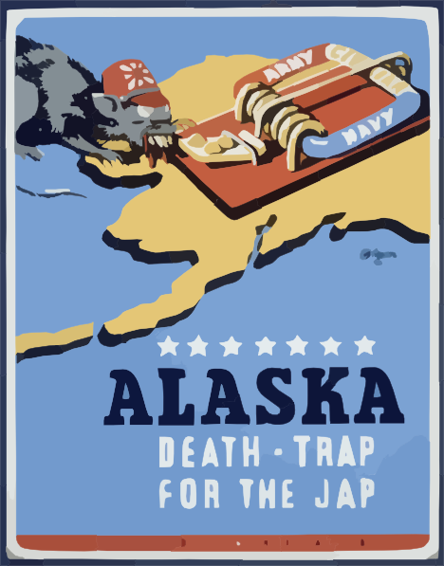

[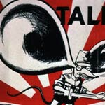](http://mason.gmu.edu/~jboggs/openseason/donttalk.html)

**A War Time Economy**

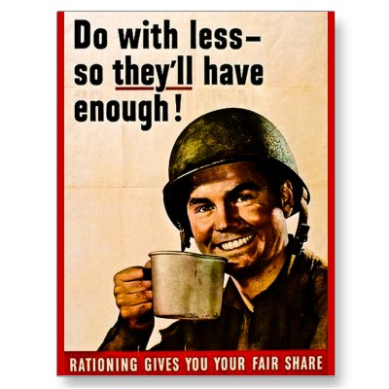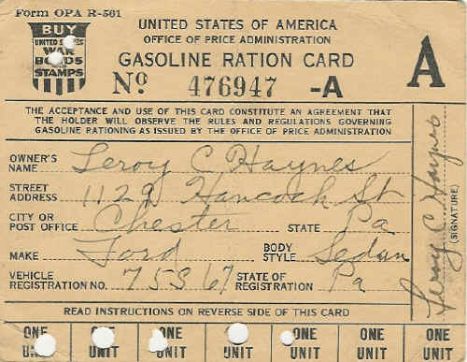

During the war, the government rationed (limitations on the amounts of certain goods that people could buy) items such as sugar, gasoline, coffee, meat, and even ketchup. Citizens were given ration books to keep track of the “points” given to each family.

|  |  |
| --- | --- |
| **Salvage (saving) in WWII** | |
| **SAVE…** | **CAN BE MADE INTO…** |
| 30,000 razor blades | 50 machine guns (.30 caliber) |
| 30 lipstick tubes | 20 ammunition cartridges |
| 2,300 pairs of nylons | 1 parachute |
| 1 pound of fat | 1/3 pound of gunpowder |
| 2,5000 tons of tin and 190,000 tons of steel | 5,000 tanks |

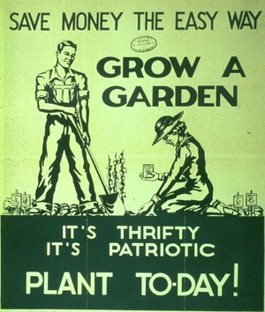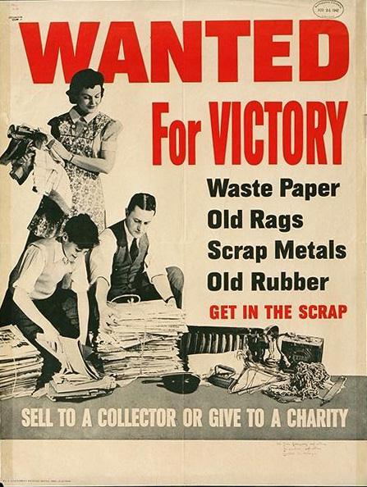

To help win the war, families, even children, went to the streets to collect scrap metal, paper, rubber—anything that could be recycled to help win the war.

During WWII, there was a nationwide victory garden program to help solve the problem of food shortages. Victory gardens made an important contribution to the home-front effort by producing a significant amount of food (approximately 40 percent of the vegetables consumed in 1943) and by providing a way to contribute to the war effort for those who could not fight on the battlefield.