Edward R. Murrow High School Ms. Sarno & Ms. Albu
#3
Allen Barge, Principal American History Semester 2

Women’s Suffrage
Introduction
In the early nineteenth century, changing social conditions and the idea of equality led to the beginning of the woman suffrage movement. By then, more women were receiving education. Women also began to participate in reform movements and become more interested in politics. Women and men began to question why women were not also allowed to vote. Supporters of this were called suffragist. Women's suffrage means the right of women to vote. The women's suffrage movement was the struggle to gain the same right to vote as men. This started in 1848 at the Seneca Falls Convention where women published the Declaration of Sentiments, which demanded equality for women. Fifty years later, their granddaughters continued the fight.

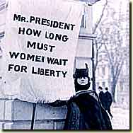
I. Alice Paul
Throughout the winter of 1917, Alice Paul and her followers in the National Women's Party picketed the White House. They stood silently at the gates, holding signs that said "Mr. President, how long must women wait for liberty?" The picketers were suffragists. They wanted President Woodrow Wilson to support a Constitutional amendment giving all American women suffrage, or the right to vote.
At first, the suffragists were politely ignored. But on April 6, 1917, the United States entered World War I. They yelled at President Wilson, accusing him of being a hypocrite. How could he send American men to die in a war for democracy when he denied voting rights to women at home? The suffragists became an embarrassment to President Wilson. It was decided the picketing in front of the White House must stop.
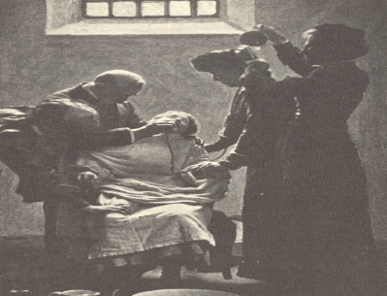
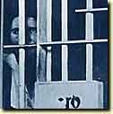
The suffragists were attacked by people. Police did nothing to protect the women. Soon, the police began arresting the suffragists on charges of obstructing traffic. At first, the charges were dropped. Next, the women were sentenced to jail terms of just a few days. But the suffragists kept picketing, and their prison sentences grew. Finally, in an effort to break the spirit of the picketers, the police arrested Alice Paul. She was tried and sentenced to 7 months in prison.
Paul was placed in solitary confinement. For two weeks, she had nothing to eat except bread and water. Weak and unable to walk, she was taken to the prison hospital. There she began a hunger strike--one which others would join. "It was," Paul said later, "the strongest weapon left with which to continue... our battle . . ."
In response to the hunger strike, prison doctors put Alice Paul in a psychiatric ward. They threatened to transfer her to an insane asylum. Still, she refused to eat. Afraid that she might die, doctors force fed her. Three times a day for three weeks, they forced a tube down her throat and poured liquids into her stomach. Despite the pain and illness the force feeding caused, Paul refused to end the hunger strike--or her fight for the vote.
Q1. What are 3 methods women used to fight for the right to vote?
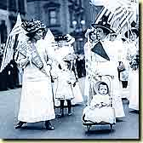
Q2. Which of these methods do you think would be most effective? Explain.
II. Success
By the time Alice Paul was sent to prison, the fight for women's suffrage had been going on for almost 70 years. It had started in 1848 in Seneca Falls, New York, at a small Women's Rights Convention. These early feminists wanted the same opportunities as men. They wanted the chance to attend college, to become doctors and lawyers, and to own their own land. If they could win the right to vote, they could use their votes to open the doors of the world to women.
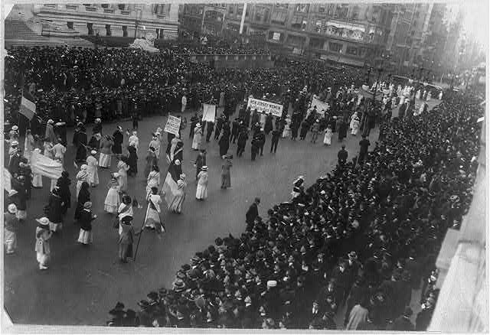
After 50 years, Alice Paul and the National Women's Party began their suffrage campaign, the old leaders of the women's movement were gone. But support for the suffrage amendment had grown. Women were already voting in twelve western states. And in 1916, Jeannette Rankin of Montana became the first women elected to Congress. Yet Congress was no closer to passing the suffrage amendment than before. Finally, on January 9, 1918, Wilson announced his support for suffrage. The 19th amendment was passed allowing all women the right to vote – this became the law in 1919.
Q3. What did women achieve due to their efforts in the Suffrage movement?
